Dear Brethren
It is my sincere hope that I find you all doing well. In Zimbabwe we are forever grateful that the Lord is keeping us healthy. He too allows us to be doing the little we can in his kingdom and for that we are thankful. The following forms the core of my activities in the month of April.
On 28 March we received nine men that stayed with us for eight days. Two men came from Chitowa, two from Bera, one from Ruware, three from Chenhare and one from Nyanga which is 700 kilometres away from Bulawayo. The men had come to attend my regular Bible Periods (history and geography) classes. I have continuously held these classes since year 2017 except for year 2020 due to the pandemic. The classes have proven to be helpful to all that have attended so far. I hope to continue with the classes for a long time. There are several men around Zimbabwe who are waiting to get the opportunity to come and I am hoping to slot another such class later in the year. I just call the classes Bible Periods but in essence I teach all important stories/events, important people and important places of the Bible and the thread that joins the entire Bible story. When one goes back, he would be a completely changed person in terms of knowledge of the Bible story.
Below: First picture men in class and second is a group photo of the men with me in blue long sleeve shirt far right.
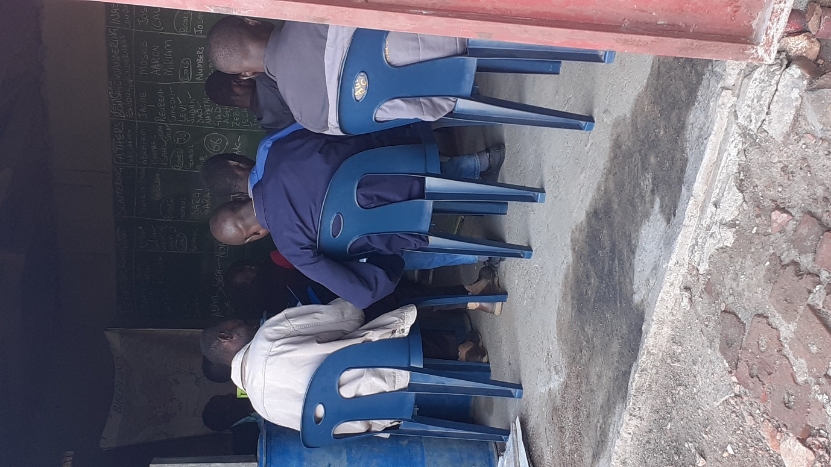
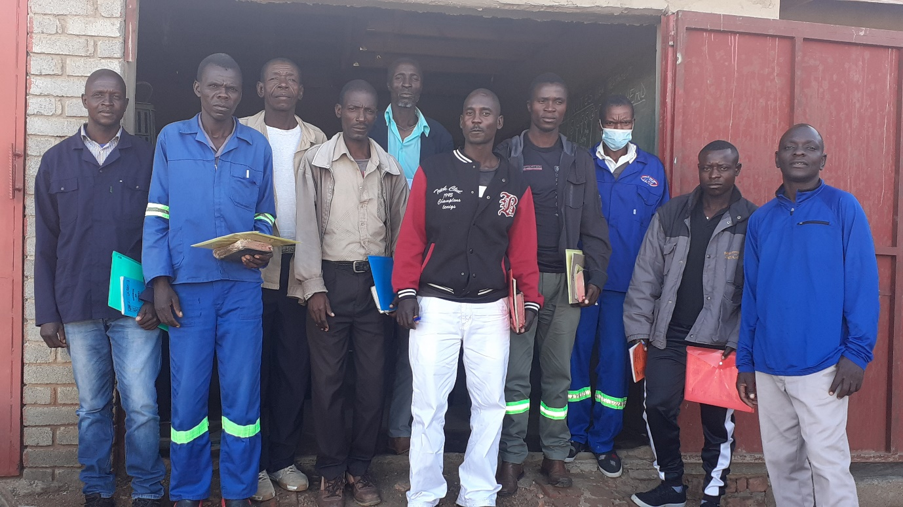

SUNDAY 3 APRIL
I taught the bible class at Hillside. For some time now, I am leading the study from the gospel of Mathew. I then preached from Genesis 3 about the sin in the garden of Eden. The sermon is uploaded on You tube titled “What really caused Eve to sin in the garden of Eden?”. As usual, this and many other uploads can be accessed by searching for my full name Professor Mashoko.
On 12 March, we then received brother Allen and sister Debbie. The previous day we had received 12 more men five from Masunda, two from Chitowa, two from Chenhare, two from Ruware and one from Bera. As soon as they arrived on Monday the 11th at midday, we went into class. The next morning until 2pm when I left to the airport to collect Allen and Debbie, we continued with the class. I had asked each man to prepare a lesson from a topic/subject of his own. So, everyone would teach the subject while all of us were listening then we would add comments. I am trying to make sure that those men who want to preach will do a good job in their respective congregations.
The 13th and half day of the 14th, brother Allen took over the teaching and he had leadership lessons prepared. The men had many opportunities of asking questions and the classes went on very well. We were really helped. The 12 men then left to their respective homes on Thursday 14 April.

Below: The 12 men busy in class. Allen teaching and I was translating into Shona to make sure everyone understood.
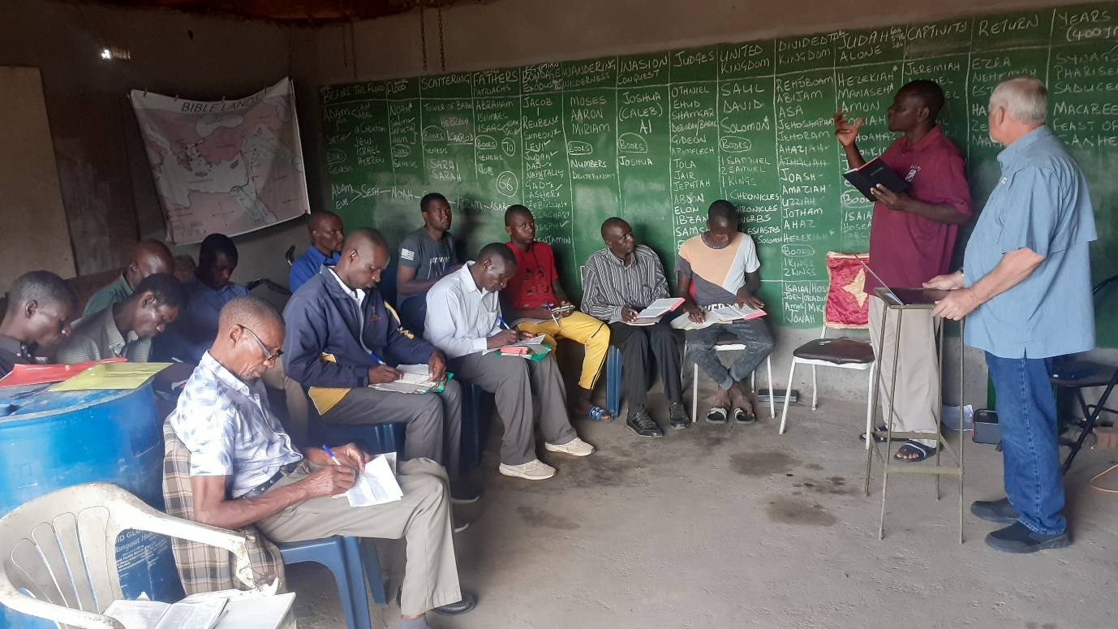

Saturday 16 April, Allen, Debbie, Nothando and myself left Bulawayo to Zvishavane where we would sleep over preparing for Sunday service with three congregations namely Chenhare, Bera and Ruware. Allen taught two lessons at each of the three congregations on Sunday 17th. The weather was not very friendly drizzling at times, but we were able to meet with all three. After the meetings, we proceeded to our rural home where we would be based for the next few days.
Below: Chenhare brethren singing a closing song.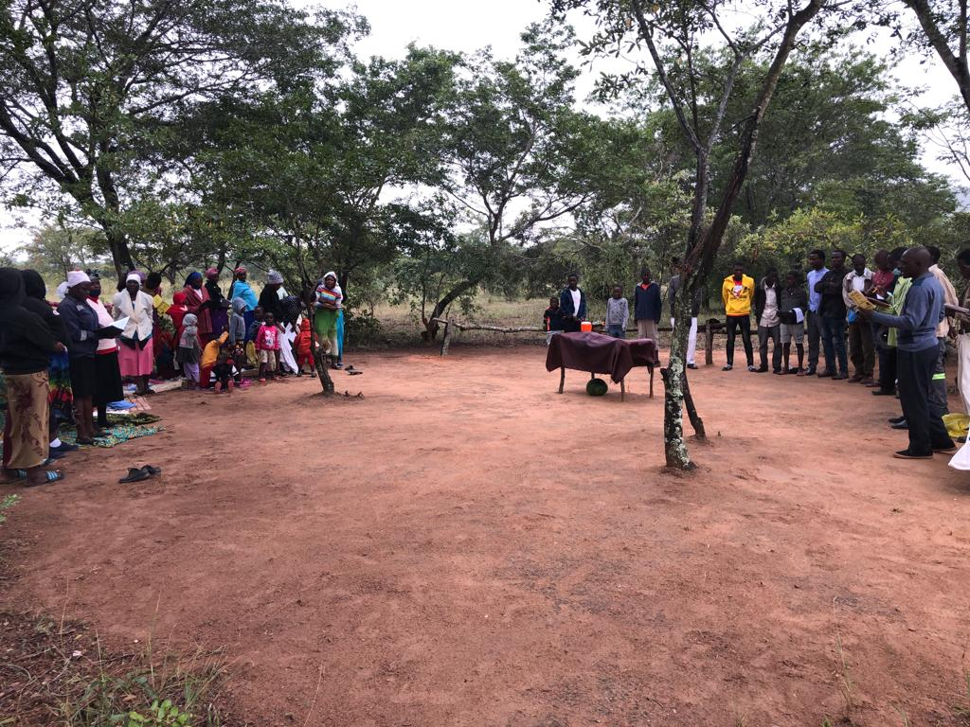
Below: the women sitting on one side at Bera Sunday service

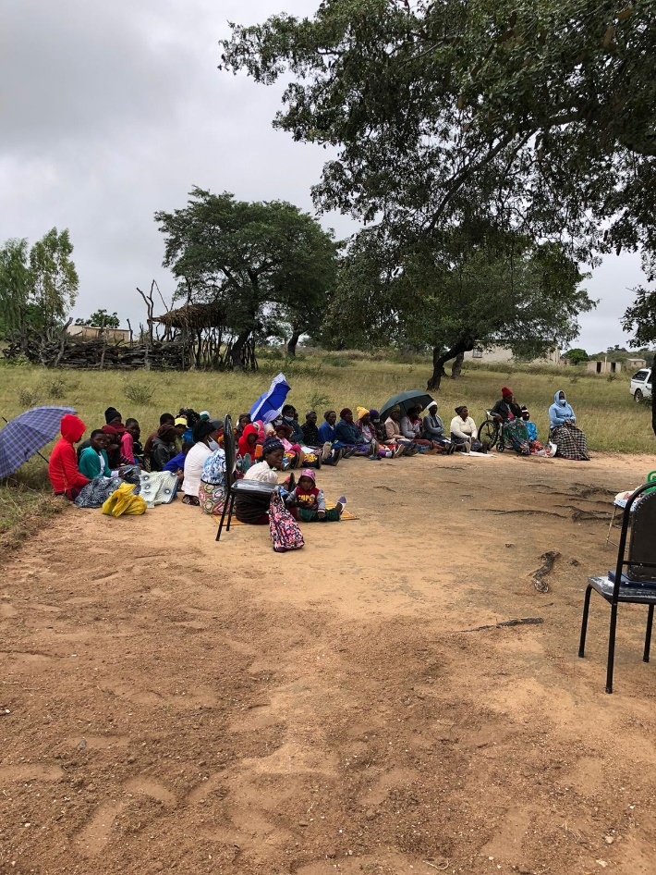

On Monday 18 April, brethren from Chitowa and Masunda gathered at our rural home for the study marriage, divorce and remarriage being taught by Allen. The studies continued on Tuesday and ended around lunch time. The lesson was well received and again both men and women had plenty opportunities to ask questions for more clarifications to be made.

Below: group photo taken on Tuesday soon after the class.

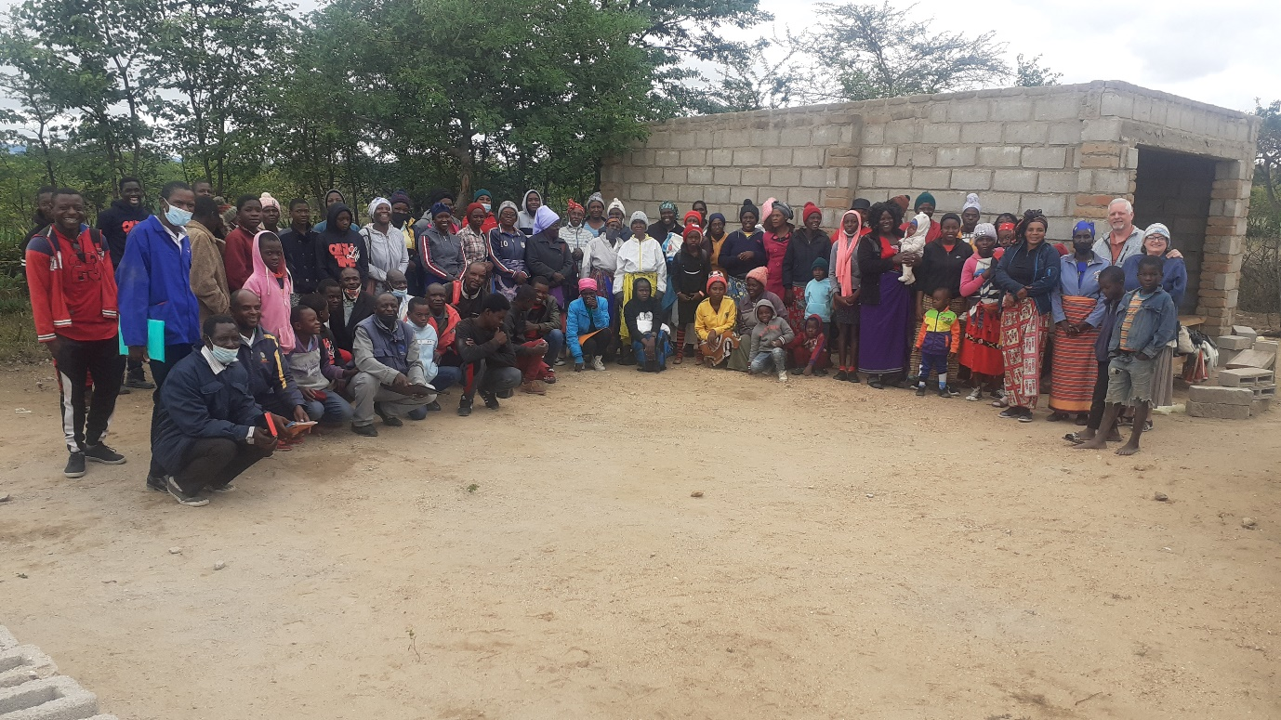

On Wednesday morning we went back to Bera area to carry on with the study of marriage, divorce and remarriage. This time the audience would be brethren from Chenhare, Bera and Ruware. The venue was Ruware meeting place. The weather was harsh and light showers would come causing much disruption. Allen had to hit the highlights of the lesson so that we could finish the same day since the weather report had focusted more rain the following day.
Below: group photo after the studies
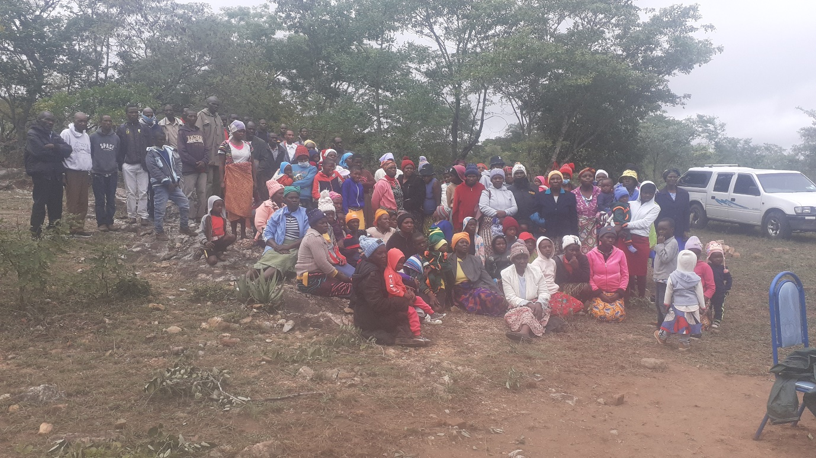
After the class, we left for Zvishavane where we would sleep over. The next morning, we proceeded to Mberengwa where the marriage, divorce and remarriage lessons would continue. We had been joined by Benjamin Muvondoni, Reason Bwatikona, his wife Theresa and their son Ishmael. We got to Mberengwa and some brethren had arrived but it started raining heavily and the meeting had to be called off. Since there was no more reason to stay, we left for Bulawayo. It rained almost the entire day and the rains were widespread.
Below: some of the Mberengwa brethren that had gathered. Benjamin, Reason, Ishmael, Theresa, Nothando and myself are also in the picture.
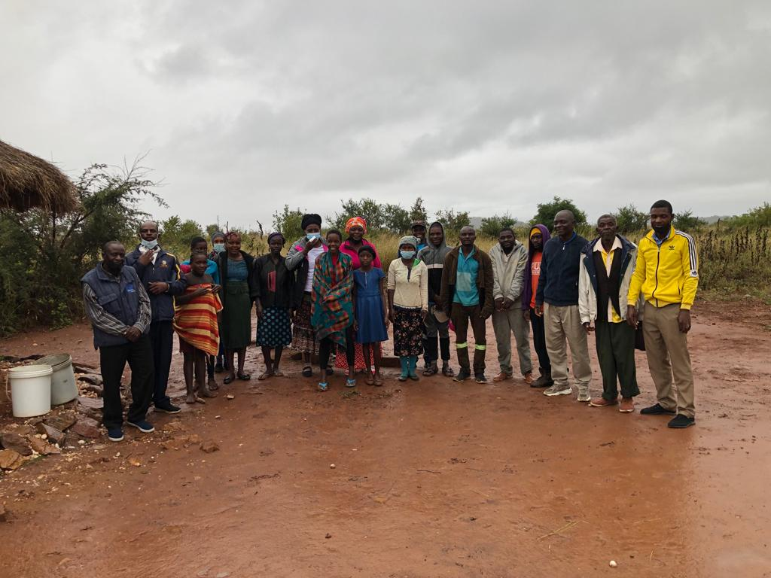

On Saturday 23 April, Hillside had organised a meeting where Allen would speak. He gave two lessons between 4 and 6pm. The next day Sunday 24th, Allen preached and taught a bible class soon after service. I led the morning study from the book of Mathew. I am now in the events that took place between chapters 23 to 28.
DROUGHT SITUATION
The situation is not looking very good. The season was so bad that many crops failed. The brethren are in need of help if KSR is in a position to help as you have always done. What is causing the situation to be harder is that there is a wave of price increases of basic commodities. Fuel too has sharply gone up and the result of fuel going up is an increase in prices. Everything is being blamed on Ukraine-Russia war. Politicians always have a tendency of finding a scapegoat even if it is them who would have failed. Just a month ago, I bought a 50kg bag of mealie meal for $17.50 from the same supplier where we buy relief food. We visited the place yesterday with Allen and Debbie while they were waiting for their PCR covid test results. The price had gone up to $22.00. The guy who is the clerk at the company was hoping for more increase soon because the maize is now being sourced from far away places and also it is not abundant in the country. We can only hold our breath.
The total number of brethren around the congregations I was given by the men from Masunda, Chitowa, Bera, Chenhare, Ruware and Mberengwa as at yesterday was 260. However, there are many movements happening where some brethren go to other places especially to look for some work. When relief comes while someone has been away for a few weeks and they will not be coming back soon, they do not receive the relief. If each of the 260 would get a 50kg that will translate to $5720. The last transport cost was $900 before the latest fuel increase. I realise the figure has sharply gone up. The food bought usually lasts for about two and a half to three months.
Thank you for allowing Allen and Debbie to come. We had a super time with them staying with us. We have managed to teach them to eat SADZA which is the staple food in Zimbabwe. The brethren both at Hillside and the rural areas were edified by the teachings. We hope to see them or any other brother or sister who may wish to come to Zimbabwe. We will be glad to host you and work with you in His Kingdom.
Greet your families and all the saints you oversee.
Your brother
Professor

