Dear Brethren
I greet you all in the name of our Lord. I am sure I find all of you and your families doing well. I hope too that the flock of God under your care is enjoying good health. In Zimbabwe we are doing well. There are no unusual health issues to report on among the brethren I work with both at Hillside and the rural churches.

I did not travel during the month of February. All the four Sundays I was at Hillside. I should have started a study in the book of Genesis with all the rural brethren from seven congregations but because of the worship ban imposed on four of the seven congregations, the study was put on hold. If I had gone ahead with the study only Masunda, Chitowa and Mberengwa would have benefited. At some point not too far from now when the ban is lifted, I would have a double job of having to travel for the same studies to the banned congregations namely Bera, Chenhare, Ruware and Mutuvi. When I do the studies especially a book with the rural brethren, I make sure I do it simultaneously across all the congregations so that the brethren get the same information at once. So I will travel to these different congregations teaching the same book. I will soon start this study.

At Hillside I am leading a morning study every Sunday which I call "Survey of the Bible story". I make constant reference to the Bible periods in this study. What is very encouraging is that the brethren at Hillside have responded so well to these studies and they are enjoying every bit of it. I am impressed by the amount of zeal and knowledge that all of a sudden the brethren are showing. Few people would dare miss this morning study. We are thankful to the Lord. I see a lot of spiritual growth in many of the brethren. But in every situation you always have some who are indifferent. I am also helping two young men my son Predecessor and Parvel Sigauke to stand up and preach. This is an effort to make sure when I am travelling which I do frequently, there is someone to preach for Hillside. They are still to get into gear and I hope with more hardwork on their part, they may be useful in the future. It takes a hard worker and many hours of personal studying of the Bible to be a preacher. Our youngsters are too busy at times to be totally absorbed by the Bible. Predecessor preached on the 5th, Allan Bent preached on the 12th, I preached on the 19th a sermon from Job 14:1-5. I did not video record the lesson as I normally do.

THE CHURCH BAN
We are confident that in the next few days, the ban will be lifted. The secretary to the Chief said to me on the phone a few days ago that they are just finishing a few technicalities and they will lift the ban soon. There is no more justification to maintain the the ban. In fact there was no justification to even ban the church in the first place. The fines were paid in full on the 6th of February. This was a total of $938 ($121 for me, $233.50 for John Makopa and $583.50 for Tichafa Munemo). Thank you for being with us through this period. Thank you for being willing to meet the costs of the fines. The ball now remains in that Chief's court to lift his ban.

FOREIGN TRIP
Lord willing, I leave Zimbabwe for the Philippines on the afternoon of Monday 20 March and depart Philippines to Zimbabwe on the evening of Sunday 2 April. This is a trip to fulfill the invitation I received from Rodelio Baagin whose facebook name is RodMarites Baagin. He has been following some of my lessons uploaded on You Tube for a long while now. Some time last year I explained to you in detail how the invitation came about. I couldn't fulfill the trip last year due to strict Covid travelling regulations which are somewhat relaxed across all countries now. Also I couldn't raise enough funds then.

This time, two congregations namely Phoenix and Silver Glen in Durban of South Africa raised my ticket fare. I have since bought the return ticket for $1108 aboard Ethiopian Airlines. Paddy and Sandi Kendall Ball are trying to raise $1500 which will take care of my transportation, accommodation and food for the two weeks I will be working with Rodelio. I am hopeful they will raise the funds before my departure date. Otherwise there could be an unwanted mishap. I will work one week north of the capital Manila in La Union province where Rodelio lives and works with three congregations. Another week I will be in Occidental Mindoro south of Manila where he used to live. My lessons will trace Jesus from the Old Testament to the New Testament and are titled "Who is Jesus?". He has asked me to also introduce the 17 Bible periods (if time permits). They are only aware of the three dispensations (Adamic, Mosaic and Christ) which are too broad. We will see how everything will go if I manage to go Lord willing.

NEW VEHICLE
The vehicle finally arrived last week on Thursday 23 February. They called me and I went to see it on Friday. It hasn't been handed over to me as they are still finalizing customs clearance. After the clearance, they will also need a few days to have the vehicle registered into the Zimbabwe system. Both clearing and registering take roughly eight working days. I should have full access to the vehicle hopefully on or before Friday 10 March. May I express my gratitude once more to KSR elders and the brethren for extending the funds to secure this vehicle. I pray the vehicle will give me a good service and will be a good tool helping me work in the Kingdom of our Father.

After receiving the vehicle, I will not immediately use it fully until I am able to put it on a full cover insurance. You may recall the near disaster in 2018 when the vehicle KSR had helped me buy was wrecked in a near fatal road accident. I didn't have full cover for it and the insurance for the bus which hit me did not compensate me fully. The full cover can be broken into a minimum of a term which is four months for $800 or a maximum of a year which is 12 months for $2400. This is the premiums for a vehicle worth $40k.

For now the good news is that the vehicle is finally here.

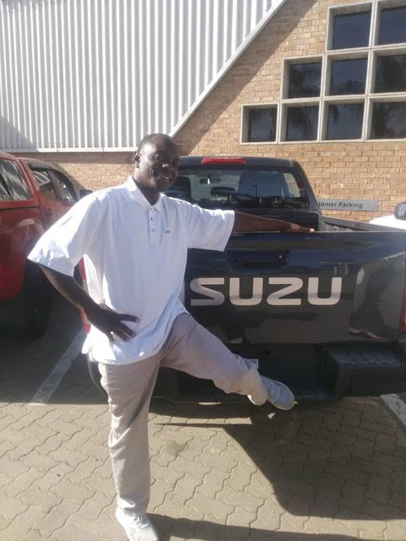

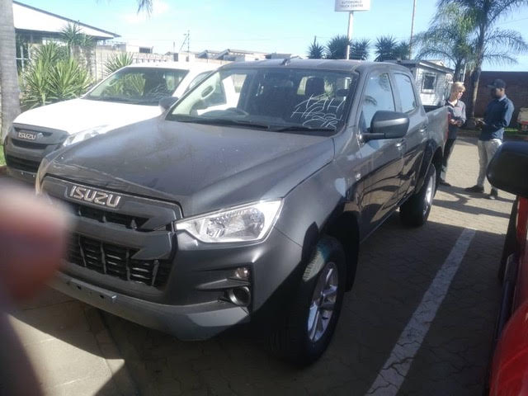

The above pictures show the vehicle.

Thank you all
Your brother
Professor

