June 1, 2023
Dear Brethren
I pray that I find you and your families doing well. It is our prayer too that the brethren that you have an opportunity to meet and see are also doing well. In Zimbabwe we are doing well. I have already told you about my son Predecessor who is not doing very well. (Gary Copeland adds, he’s been suffering with kidney stones, and they’re hoping to avoid surgery.) He is under medication and should go for a review in two weeks. We pray by that time he would have shown noticeable signs of improvement. At the moment he is better than the stage he once got to a few weeks ago. If he remains on that trajectory, he should be fully recovered soon. We appreciate all the prayers that mentioned him and still appreciate more prayers.
The following is a short report of some work I did in May.
Sundays 4 ,11 & 25 May
On all these three Sundays I was at Hillside. I taught in the Bible study classes before service which is what I do every time I am not travelling. I am teaching the overview of the books of the Bible. I am currently in the book of Numbers.
Sunday 18 May
Nothando and I travelled to Torwood in Kwekwe. I mentioned this area in my recent reports. We have already visited this place three times between April and now. There is a congregation which began there with a few people so far but we hope to make more visits in the future and pray the Lord may open more doors to more people.
We had a study on Saturday 17 May with a few people who came and we then worshipped there the following day on Sunday morning before we travelled back home. The area is around 230 kilometres away from Bulawayo. The following two pictures of those present on Sunday were taken after service.

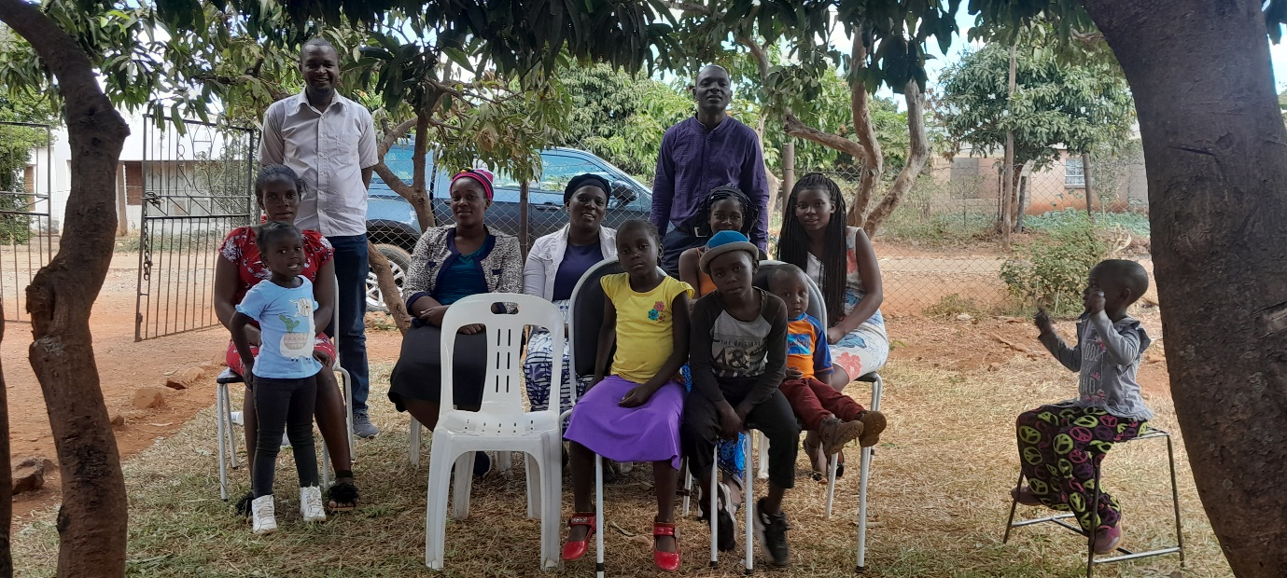
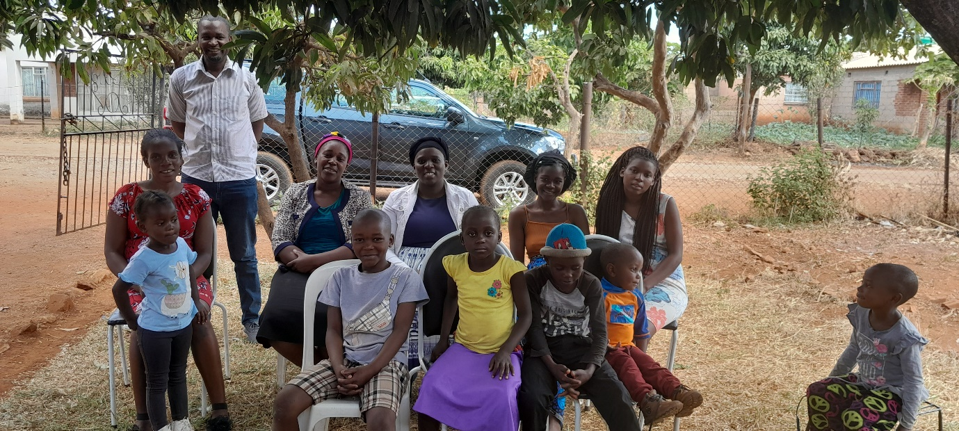
GENERAL OUTLOOK
Zimbabwe is awaiting to have elections on 23 August this year. So far there is peace around the country but as political parties begin their campaigns, we anticipate several clashes that will cause destruction to property and even loss of lives. Once the campaigns begin, our mobility to preach and teach will be curtailed. The environment usually becomes toxic during election seasons. We pray God will be upon this country and particularly His saints that they may not be adversely affected by these earthly goings on. Your prayers are well appreciated.
Your brother
Professor

