Dear Brethren
I greet you in the name of our Lord and I am positive that this email finds you doing well with your immediate families. I am sure also that the flock of God that you oversee is enjoying good health. In Zimbabwe we are doing very well. We are thankful that God is always faithful and is providing comfort to his saints. We do not have many cases of serious illness to report. My son Predecessor’s health is a bit of a “mystery” to us now. One week he is feeling fine and is walking about then suddenly, his graph plunges and for another week he is needing serious attention as he is weak and loses appetite completely. Last Sunday on June 25 he could not go for service because he was struggling yet the previous Sunday June 18 he even preached at Hillside. As I am writing today June 30, he is walking about and eating well for the past four days. The last visit to the doctor two weeks ago showed on a scan that the stones were still visible but the doctor suggested that he is also showing signs and symptoms of having too much acids. If someone asks me about how he is doing, it is very difficult to say he is recovering or he is not. We continue to monitor him and see if there is anything else that we may need to do. Thank you for the prayers.

The following is my report of the work I did in Zimbabwe in June.
Sunday 4 June
I was at Hillside where, as always, I taught in the morning bible class. I am doing a survey of the books of the bible. On the day I concluded the book of Numbers. I then preached in the service about a need for every Christian to grow spiritually. The lesson is uploaded on You Tube titled “Spiritual Growth”. As usual searching for my full name Professor Mashoko on You Tube gives access to this and many other lessons uploaded there.
Wednesday 7 to Friday 9 June
Nothando and I were travelling. We left Bulawayo on Wednesday 7 June heading to Bera area where we had a study with brethren from Bera, Ruware and Chenhare. In April I had started a study of the book of Genesis and gone half way. So on this day I concluded the book. The following are the brethren who attended the study.

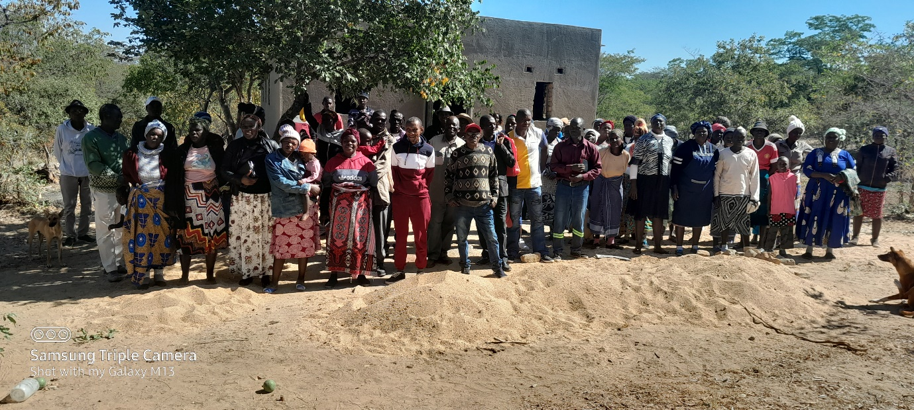
The following day Thursday June 8, we proceeded to Masunda to also conclude the book of Genesis and the following are those brethren who managed to come.

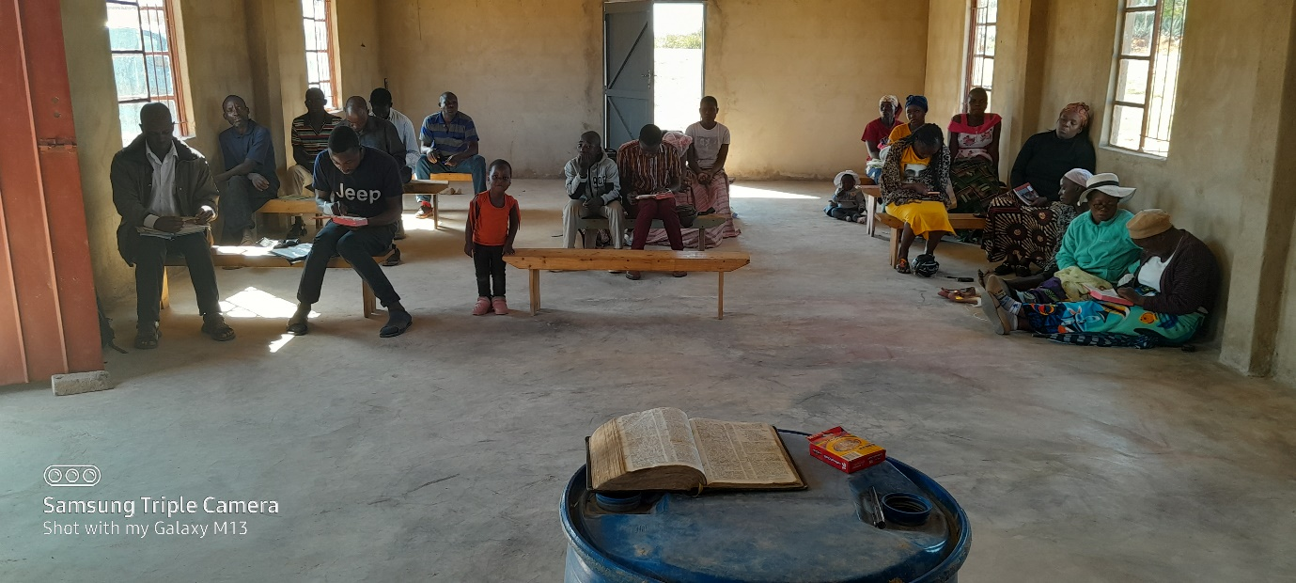

Finally on Friday June 9 we were at Chitowa doing the same study from Genesis. When I begin a study of a book, I make sure I do the study at all these rural places where I teach to make sure that none of them remains behind. Soon I will begin a study in Exodus and it will be done in the same fashion. The following two pictures show Chitowa brethren inside and outside the building.
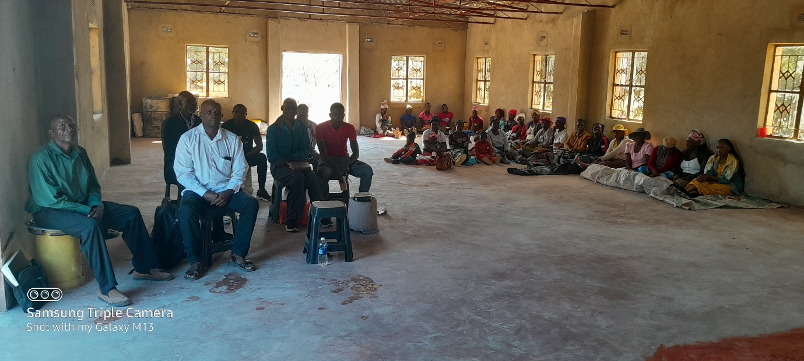
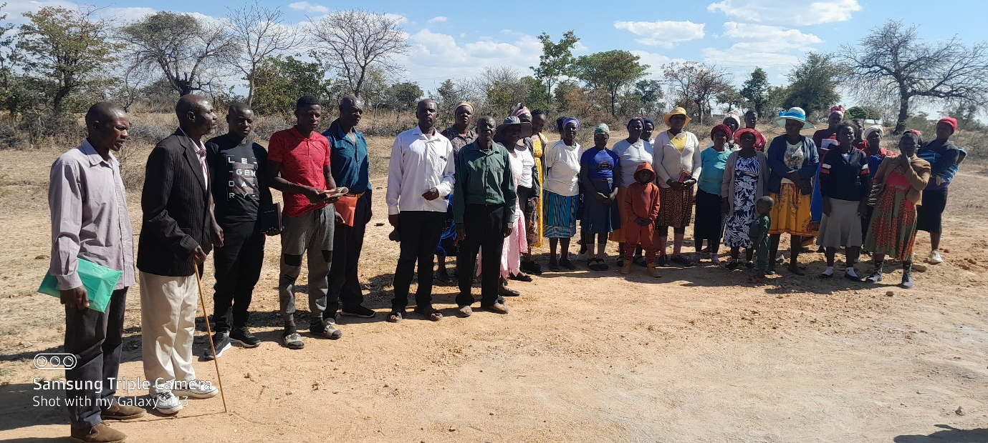

Sunday 11 June
We met with Masunda brethren. I was asked to teach in the bible study before service and our study was from Hebrews 12:1-2. After service, we drove back to Bulawayo and we arrived safely. The first picture below shows brethren inside the building. I am seated with Reason on the front bench and I am second from the wall. Nothando is sitting on the front bench to the wall and wearing blue top. The second picture shows brethren standing outside the building. I am squatting to the far left of all those squatting.
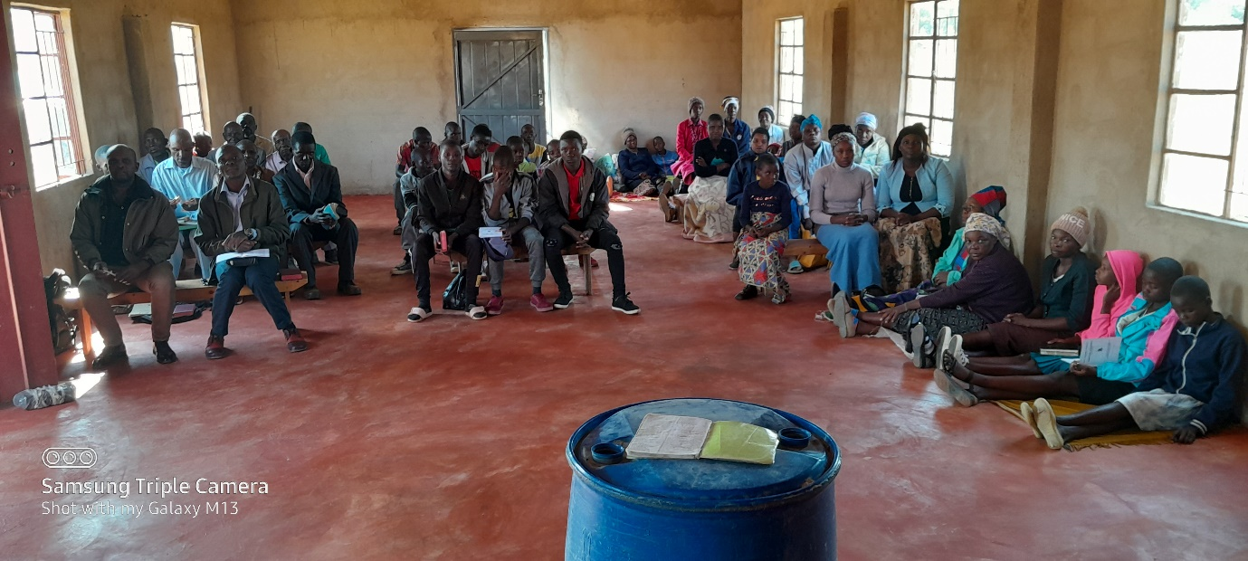
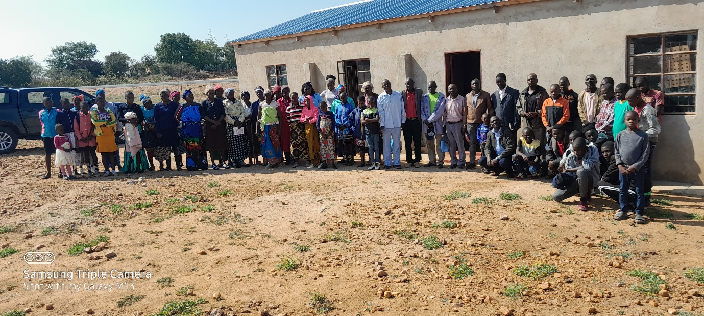
Future plans
Zimbabwe is holding general elections on 23 August. The country is busy already with those who are campaigning canvassing for support. This is a season which inevitably disturbs our preaching especially in the rural areas. Since I completed Genesis with the rural brethren, I am planning to begin a study in Exodus. August is school holiday in Zimbabwe and travelling and teaching during that time gives better results. We will see if the political climate would not have polluted the environment. We hope to receive brother Allen and sister Debbie early September. We also hope the political temperatures will be cool enough to allow the work of our Father to be carried out during their visit.
Send our greetings to your families and all the brethren in your company.
Your brother
In Christ’s love
Professor

