Dear Brethren
I am writing the following to firstly thank you for a quick positive response to the request of relief for the rural brethren I work with in Zimbabwe. Secondly, I would want to thank you for your continued willingness to help these brethren. You have stood with us for some years now and you lessened the burdens of these brethren. We are really grateful to our Lord who has blessed you with good hearts to share your material possessions with us even though we are such a great distance away from you.
I received the money in total of $6920 on Wednesday 4 May and picked it up from the bank. I proceeded straight to the mealie meal producer where we usually buy the relief mealie meal. The revised numbers of the brethren to benefit had come down from 260 as I had written in my request report to 254. So, I purchased 254 by 50kg bags. The price was $22 per bag. I went to the manager’s office to ask for some discount. He gave me a discount of fifty cents per bag. I eventually paid $21.50 per bag.
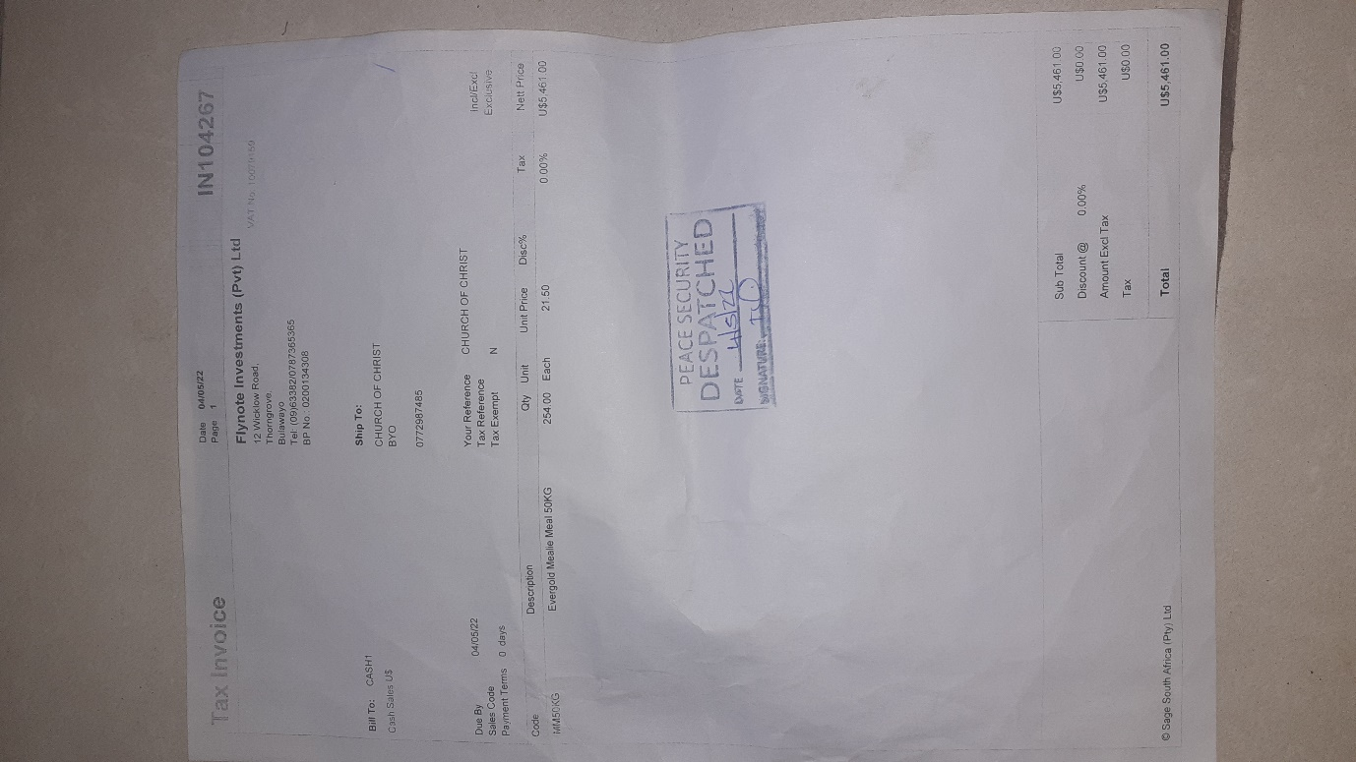
The total tonnage was 12,7 tonnes of which the 10-tonne truck I hired to carry the food last time was now small. I needed a 15-tonne truck. I went around and found one and we loaded the mealie meal.
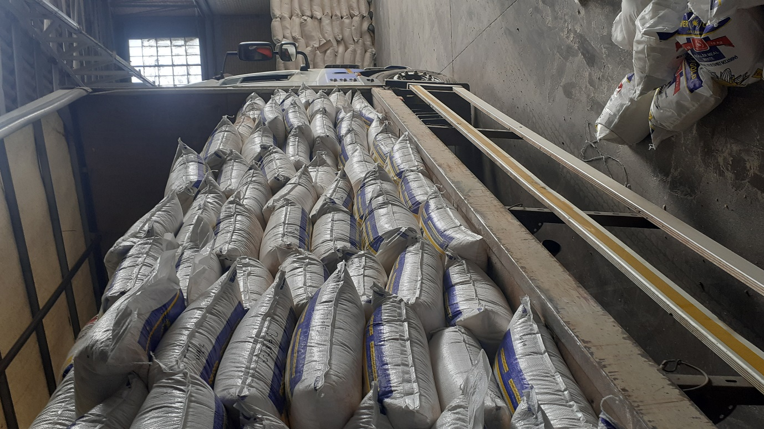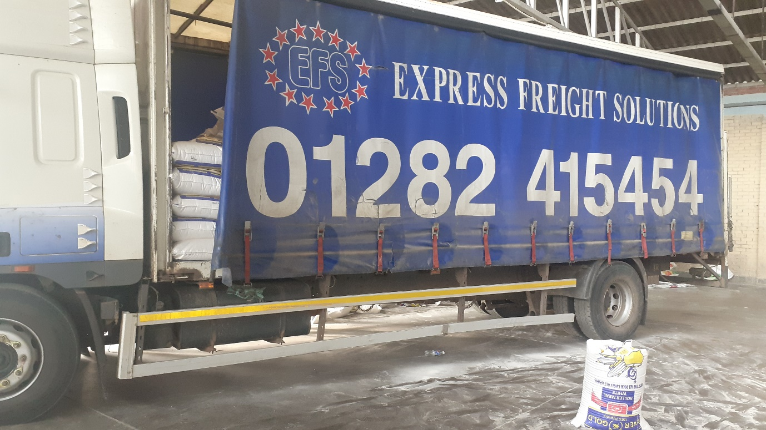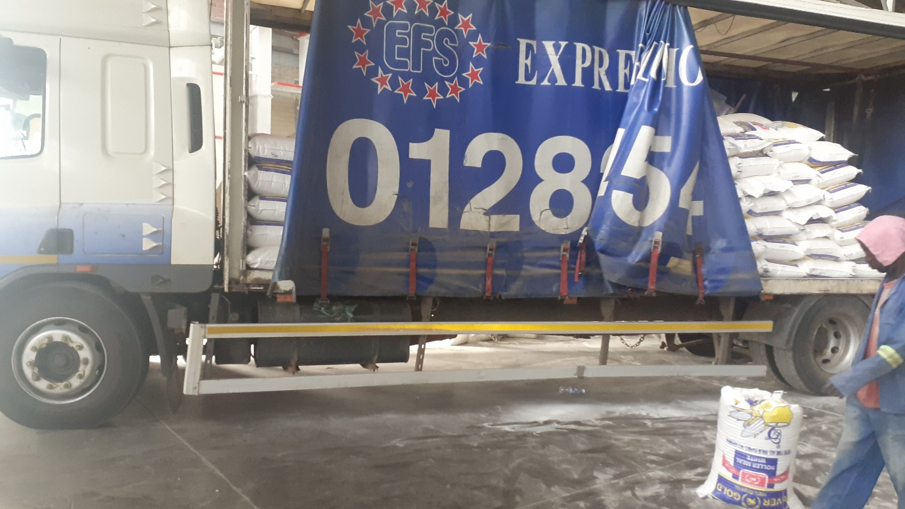
That evening we left Bulawayo around 8pm headed to the rural areas. I escorted the truck in my car to the six places that would receive the food.
First to receive in the morning of Thursday 5 May were brethren from Chenhare. At all the six places you will see bags standing without anyone behind them. It was a school day hence the school going beneficiaries were not present. Even some adults were not present for various reasons because they had received a short notice to gather. They will get their food from fellow brethren who received on their behalf.

Chenhare brethren present
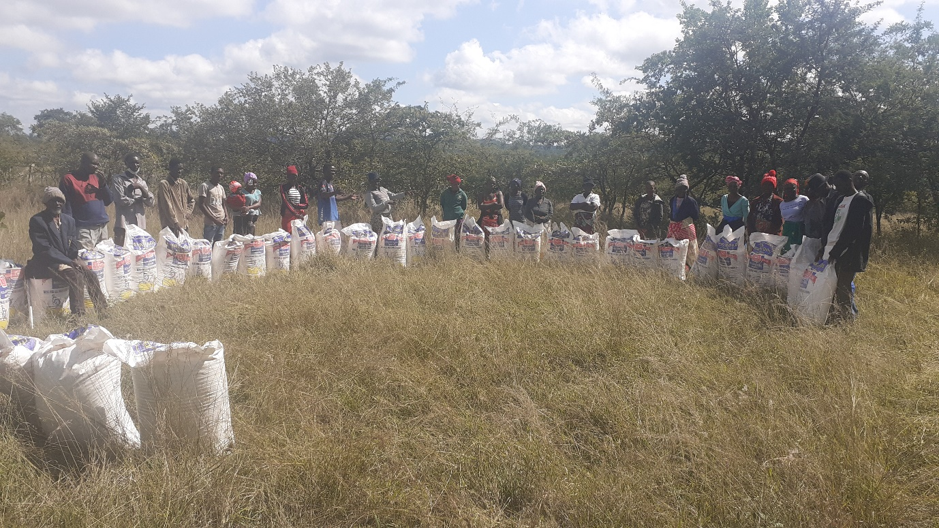

Second to receive were brethren at Bera brethren.
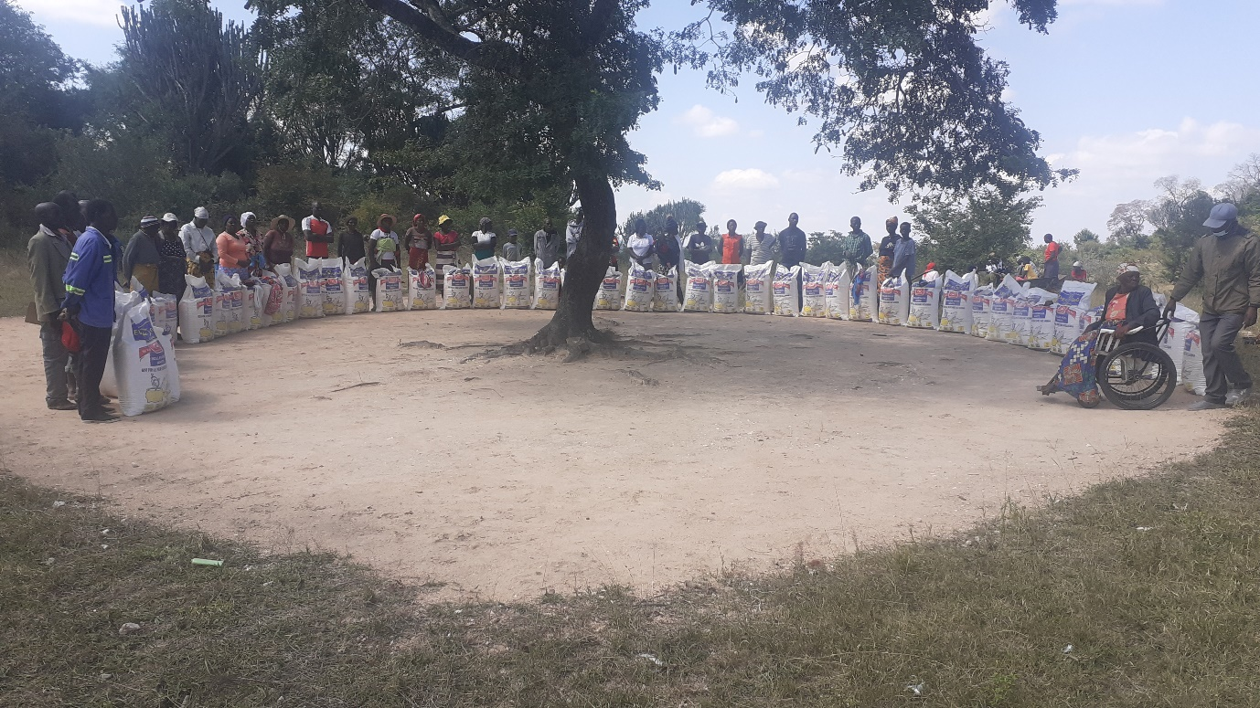
Third to receive were Ruware brethren. The road to their meeting place cannot be accessed by a big truck. I asked them to come over to Bera meeting place to receive from there.

Ruware brethren
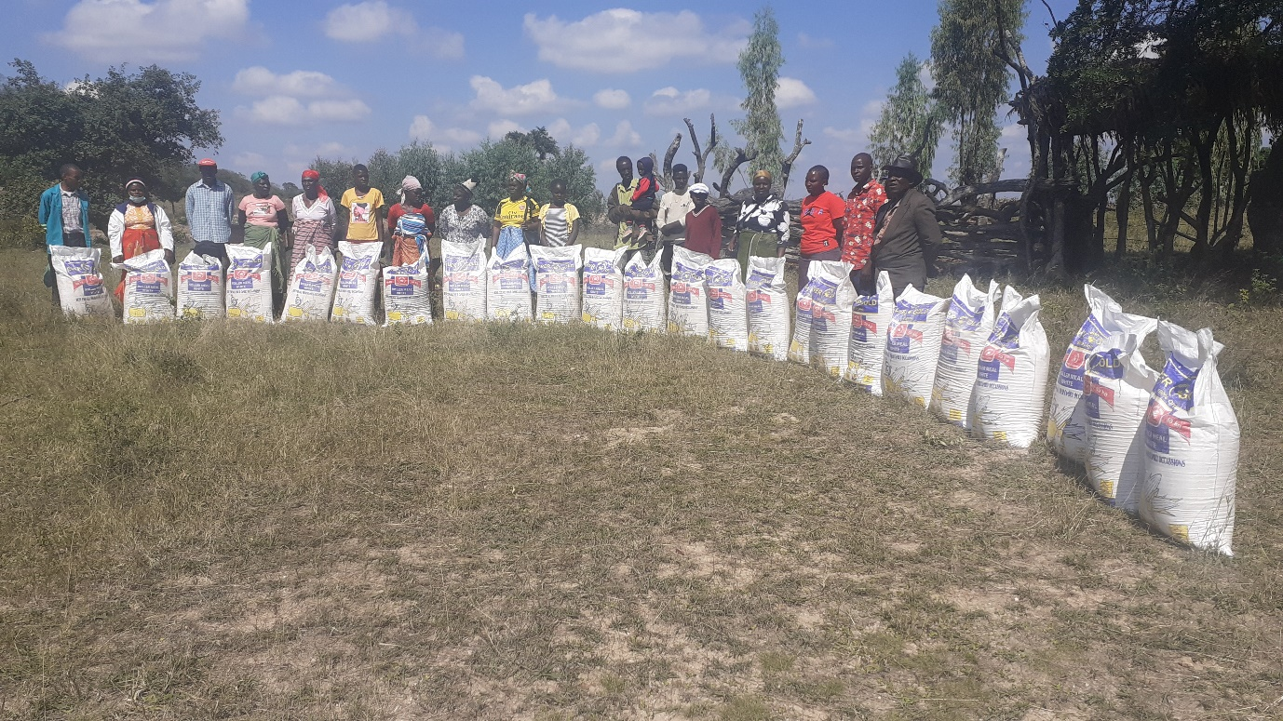
Those from Masunda who were able to gather at short notice came to their meeting place and they received their food too.
Masunda brethren with their food
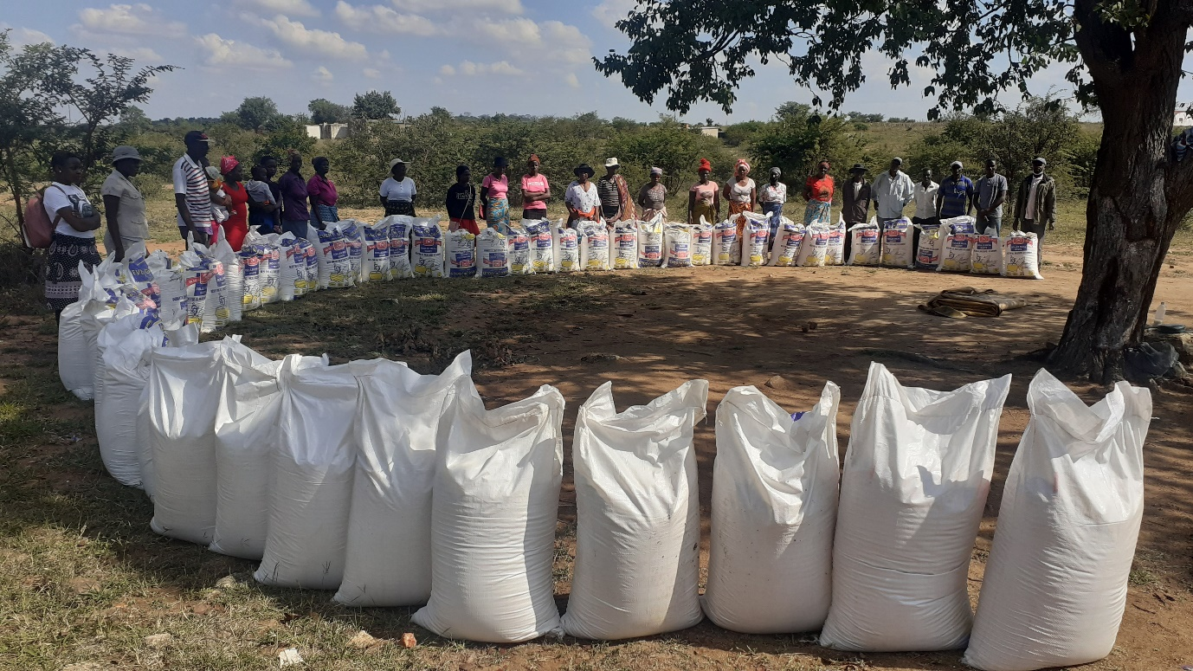

From Masunda, we went to Chitowa and below the Chitowa brethren and their food.
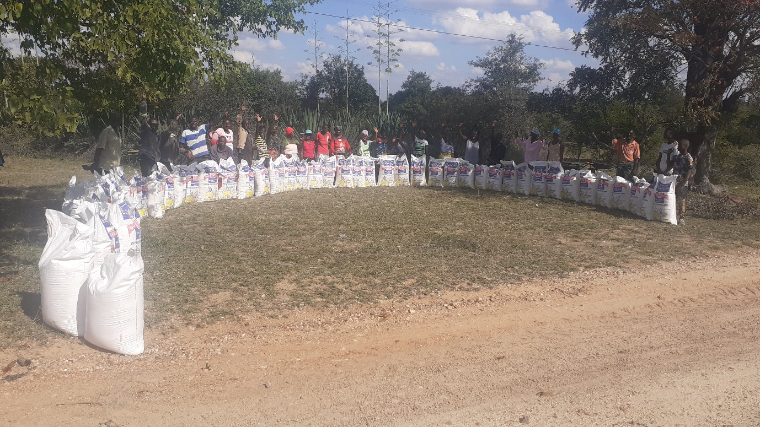
After Chitowa, we proceeded to Mberengwa and below are the Mberengwa brethren with their food.
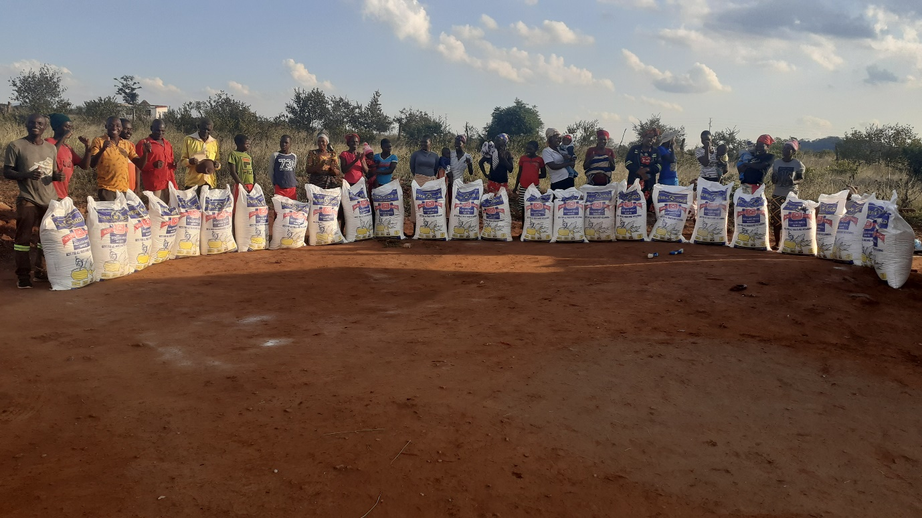
The hired truck just offloaded at Mberengwa and left for Bulawayo. I remained with Benjamin, Reason, Rodric Gwanongodza from Masunda and Tawanda Mapipi from Chitowa who had accompanied us. I travelled back to Bulawayo later and arrived safely.

Below is a usual letter that Benjamin and Reason write
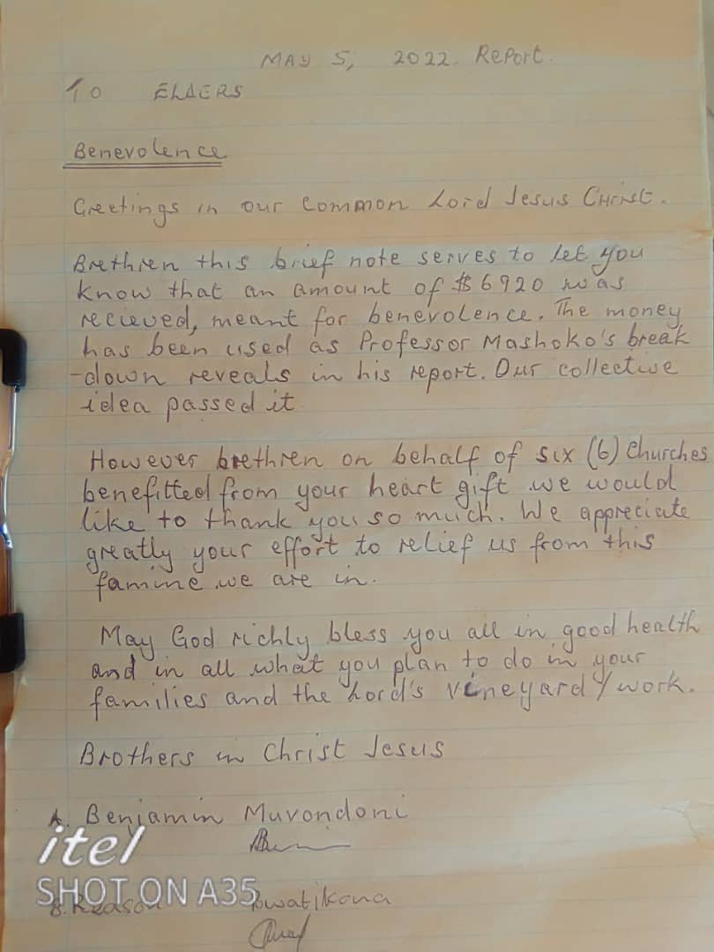

Each person received a 50kg bag of mealie meal. This should on average last until mid to end of July. The total number of beneficiaries was 254 broken down as follows,
Chenhare : 49
Bera : 54
Ruware : 28
Masunda : 50
Chitowa : 47
Mberengwa : 26

The breakdown of the funds is as follows;
Mealie meal cost : $5461
Transport (Hired truck and my fuel) : $1050
Medical : $300
Food/refreshments/airtime/labour : $109
Total : $6920

NOTES
There is a man at Bera called Jabulani Hingi. He had a surgery in January 2021 at Mpilo Central Hospital in Bulawayo. They were repairing his intestines that had been damaged by high level of acids. He spent a full month of January admitted in hospital. He felt better after that. In April 2021 he even came to Bulawayo to our house for the men’s classes and spent 12 days with everyone at our house. This year in April he came for the leadership classes that were led by brother Allen at our house in Bulawayo. He is the one in the following attached picture whose head is half circled by red and green ink.
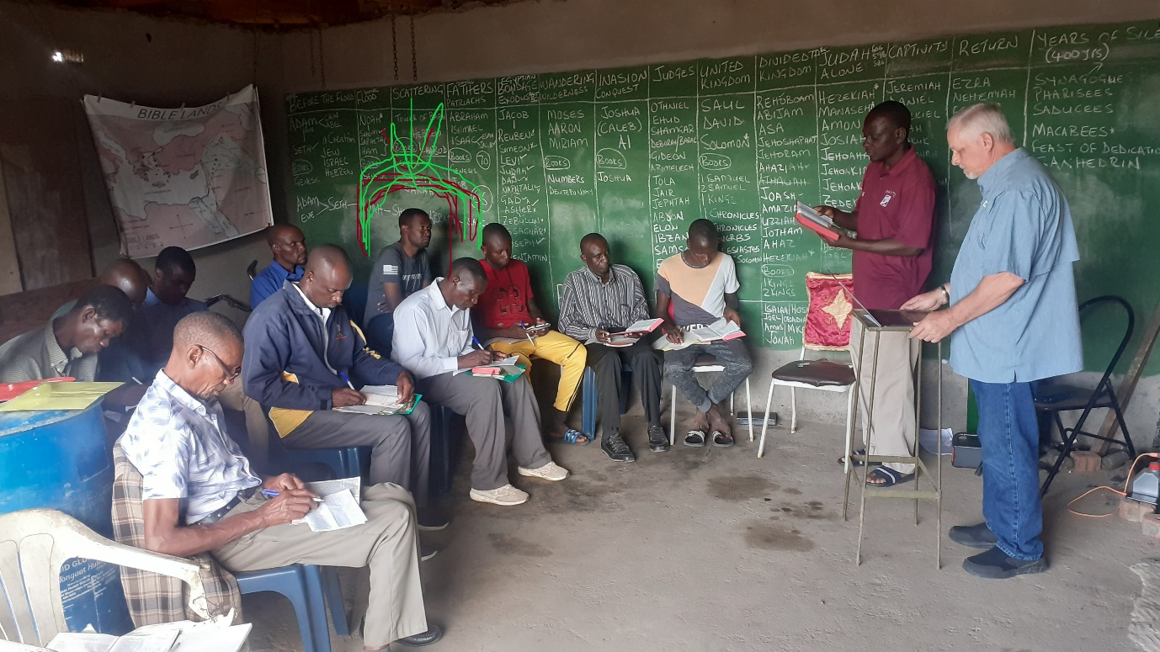
A week later when we went to Ruware where brother Allen was to teach marriage, divorce and remarriage to brethren from Bera, Chenhare and Ruware, he was absent and I was told he was not feeling well.
He went to see the Doctor and some X rays were done. It was discovered that there is a lump which has developed inside his stomach which is now about the size of an adult’s fist. They can’t tell what it is unless they carry out a CT scan which needs $300. But they also discovered that he needs an urgent surgery for hernia repair.
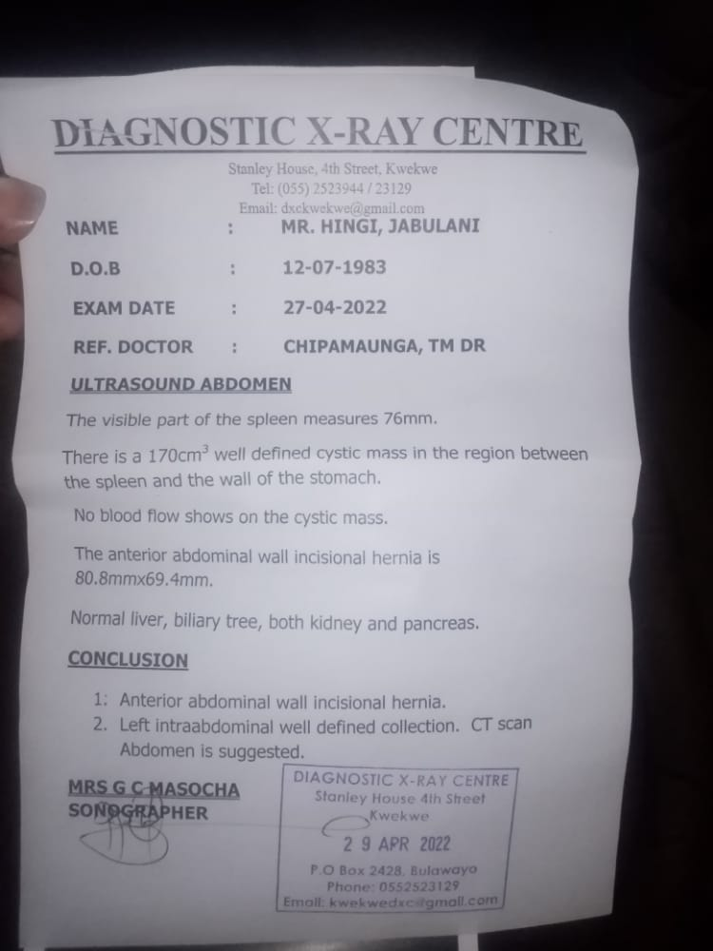
The $300 that was left after the food was bought and transport was paid was given to him to help somewhat. Thank you brethren.
Professor

