Dear Brethren
I hope I find all of you doing well together with your families and the Lord’s flock that you oversee at KSR. We are doing well in Zimbabwe. I will present underneath the breakdown of how the relief funds you sent were used.
I received the funds ($6920) in full on Tuesday 25 October. This was earlier than the date I would travel which was Wednesday 2 November. I was accompanied on this trip by Predecessor my son from Bulawayo to Masvingo where we were joined throughout the distribution by Reason and Benjamin. We changed the supplier this time around and bought from a new supplier in Masvingo town. The traditional suppliers in Bulawayo were charging $22.5 per 50kg bag and we would pay transport separately. In Masvingo the new supplier was charging $20 per 50kg bag. The $2.5 we saved per bag bought us more mealie meal from 260 bags we bought in August to 290 bags. The total cost of mealie meal was $5800, Transport cost was $800, Medical $50, labourers who loaded the truck in Masvingo $50, My fuel and refreshments $220.
NB: The $50 mentioned above as medical was given to Mufaro Majasi a 78-year-old man from Mberengwa church. He is seated in the following picture dressed in yellow shirt. He is swollen from the waist to the toes. He went to the local hospital and the doctor wrote a prescription. No advanced tests were done to establish the cause of the swelling. He finished the prescription and was due for a review on Friday 4 November but did not have money to go. He said he had slightly improved after finishing the meds. We saw him the following day on the 5th and I gave him the $50 to go for the review today Monday. I am still to hear more about the visit.
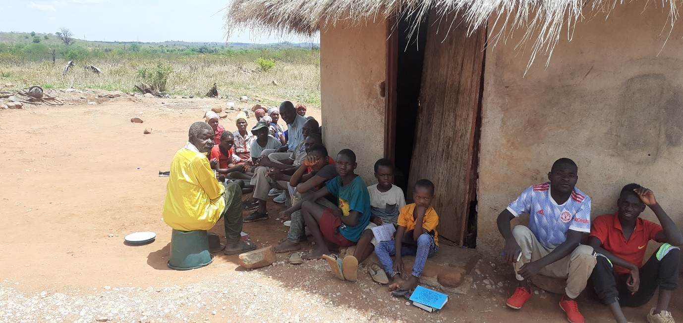

The following is the mealie meal invoice. The distribution was done on Saturday 5 November. The truck we hired is an 8-tonne truck. Our consignment was 14,5 tonnes. Two trips were made. The first trip with 131 bags was distributed to Masunda, Chitowa and Mberengwa and the second trip with 159 bags was taken to Bera, Ruware and Chenhare.
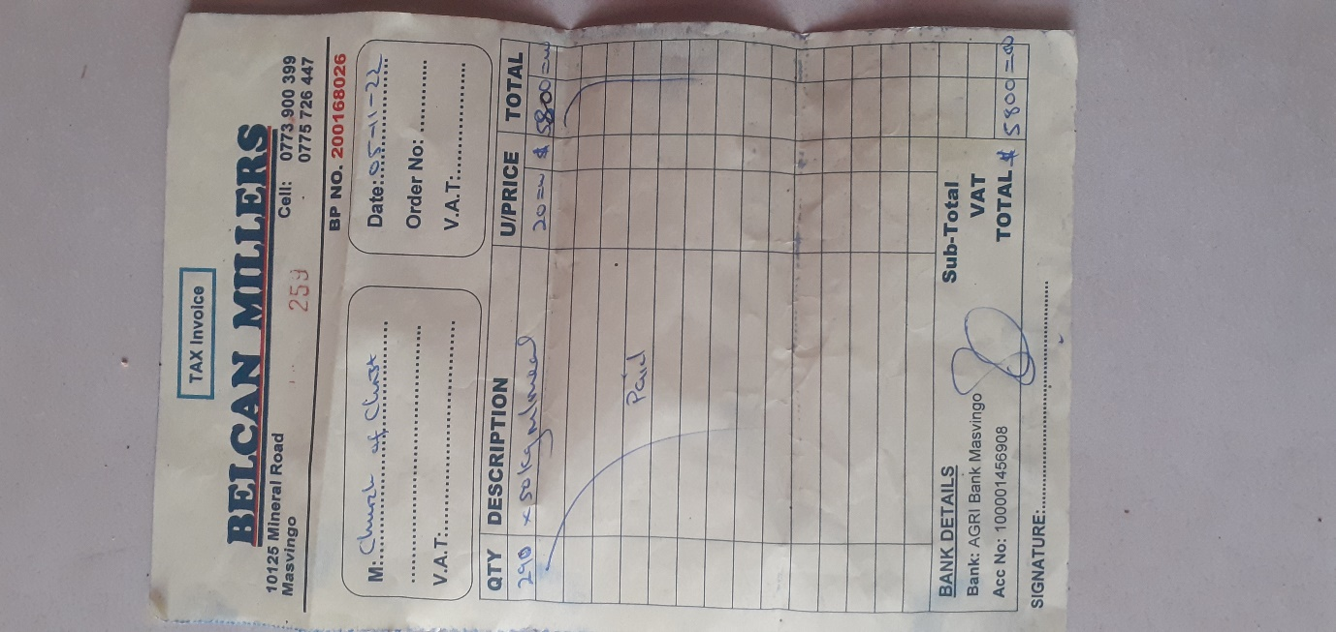

Ruware brethren with their mealie meal.
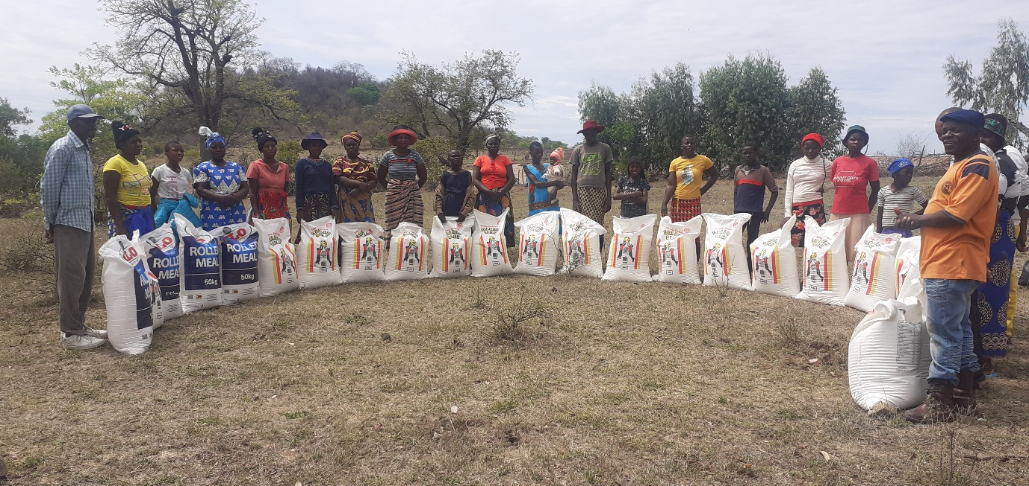

Bera members with their mealie meal.
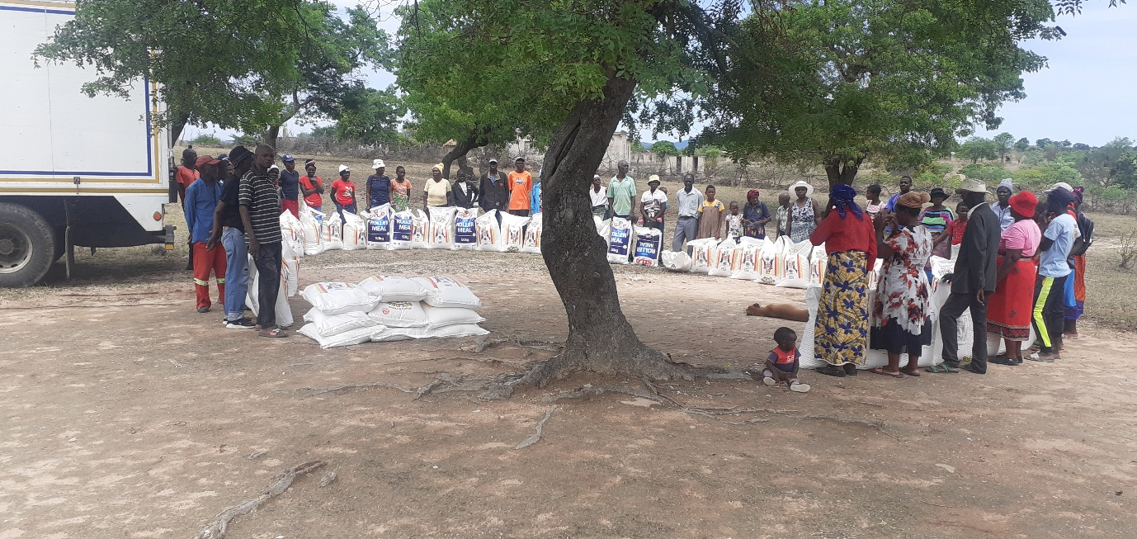

Chenhare group with their mealie meal.
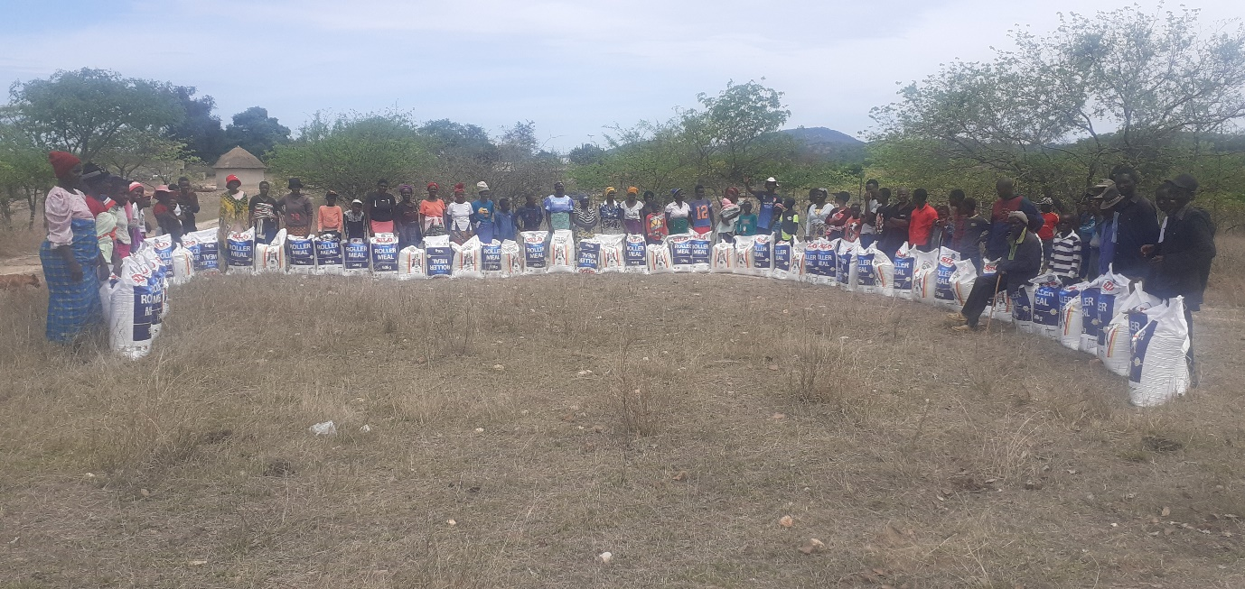

Chitowa group and the mealie meal with their up coming church building behind them
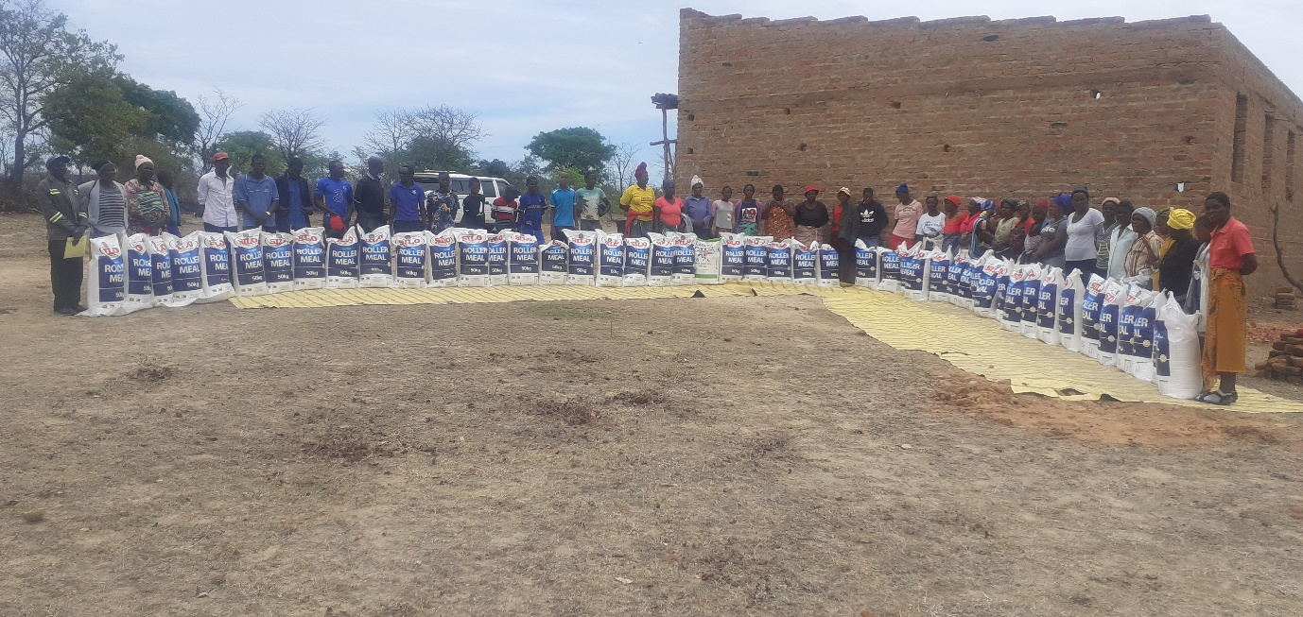

Masunda brethren with their mealie meal also standing in front of their now finished church building
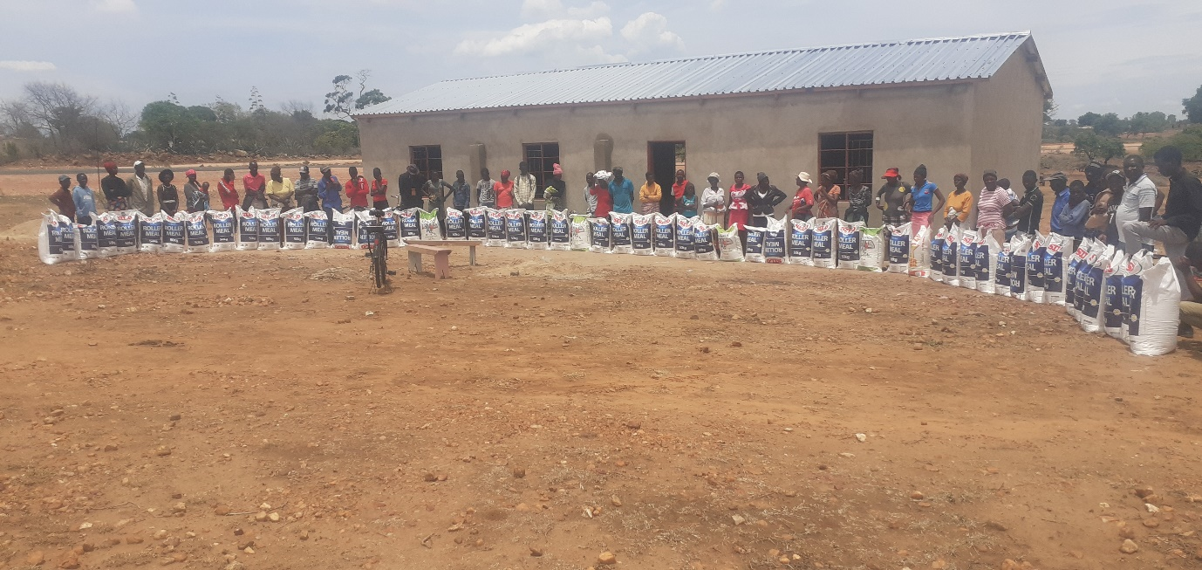

Mberengwa group and their mealie meal.
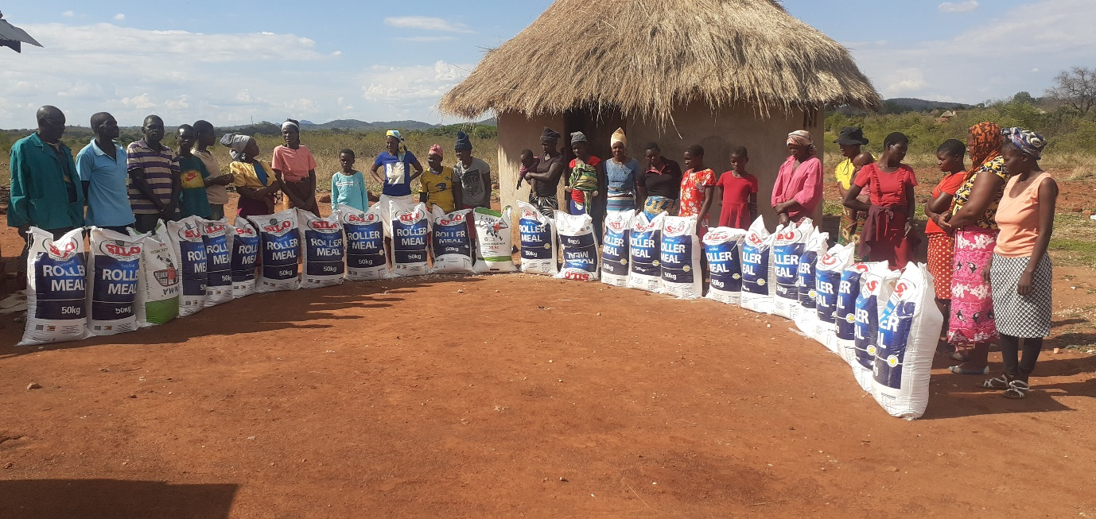

The truck we hired to transport the mealie meal to every corner it was required.
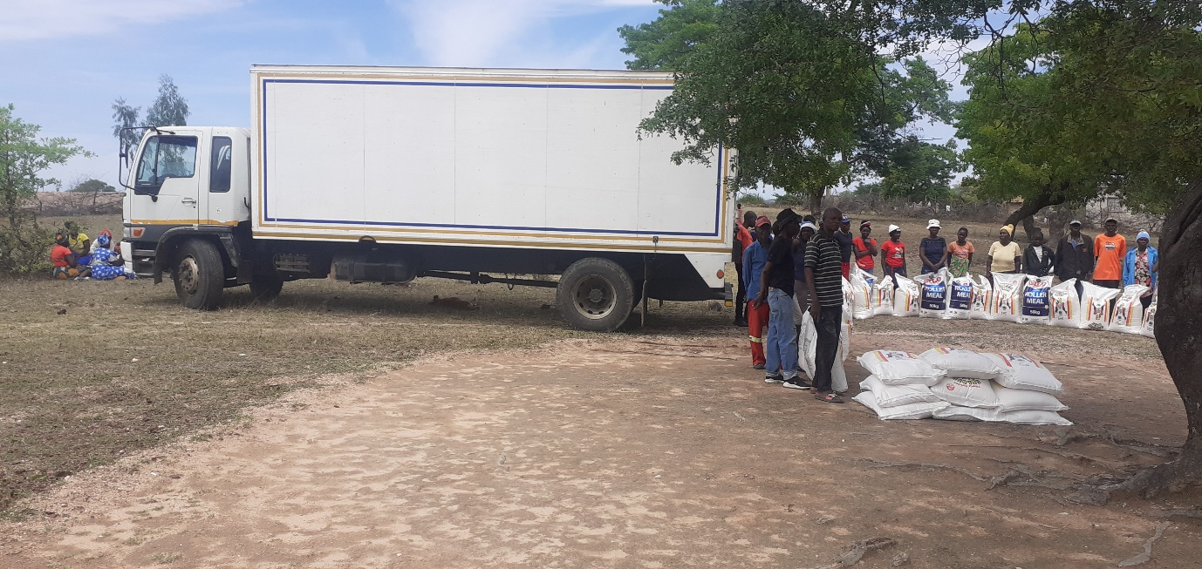

The letter written and signed by Reason and Benjamin.
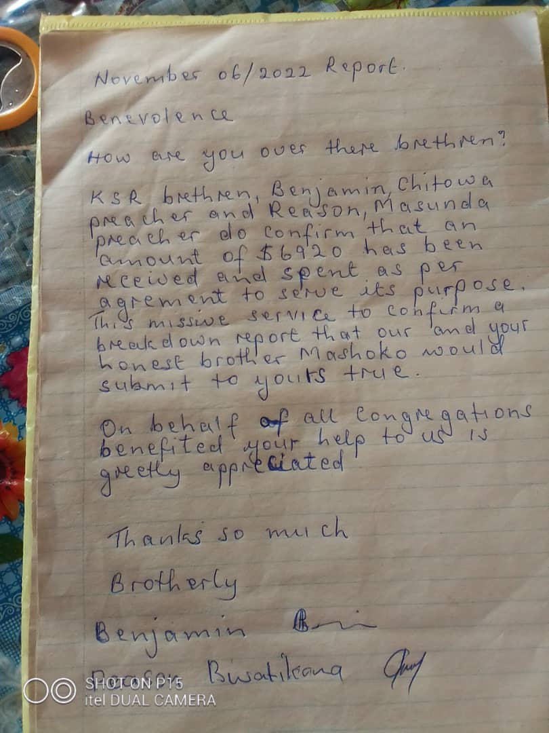
Thank you for the funds brethren. We continue praying that God may continue blessing you with the generous heart. We are grateful. We hope the food that was distributed will last approximately until end of January. The country has received some sparse rains. The Meteorological Department has advised it is not yet time to plant. It is our prayer that maybe this forthcoming rainy season may be good and people may plant and have good harvest around April next year.
Thank you
Professor

