Puerto Rico Work Report (November-December 2022)
Caleb Westbrook – HC 2 Box 47421, Sabana Hoyos, PR 00688
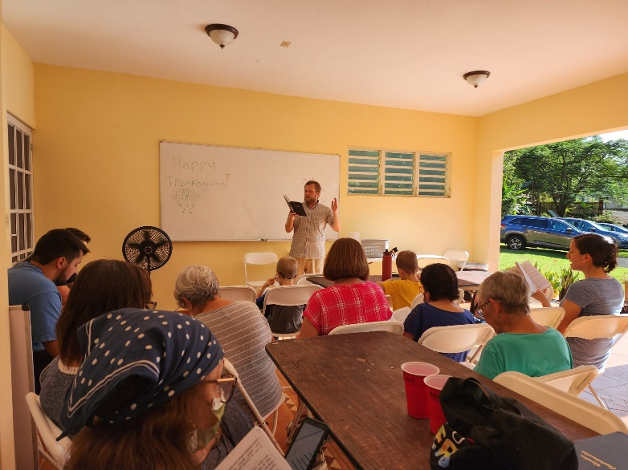
713-304-9770/ westbrookcaleb@gmail.com

Greetings Brethren of Christ’s holy church,

My family and I send our greetings to you and your loved ones for this wonderful New Year! We pray that God will protect and prosper your way for His glory in this upcoming year. As we look back on 2022, we give thanks for all the tremendous blessings that God has brought our way. In the past year we had several milestone events: we moved from San Sebastian, sold our house, the Huggins family moved state-side, we had gospel meetings with Brigham Eubanks and Roger Polanco, we made it through hurricane Fiona and its aftermath, we have gone through difficult challenges with the group in Arecibo, and Kaitlin went through the first two trimesters of her pregnancy. All in all, it has been a very busy but productive year full of blessings. We give thanks to God for leading us through the ups and downs of the past year.
Singing at our house on Thanksgiving

This time of year always brings about a fair amount of nostalgia for us. It is a difficult change of pace here in Puerto Rico, having grown up in north Missouri with the rise and fall of the seasons and the strong winters. Kaitlin always misses the fall and winter, and even while I am thankful for the Puerto Rican reprieve from the cold, I still understand that feeling of missing the cycles of the year that the States have. Puerto Ricans celebrate the holiday/Christmas season from mid-November till mid-January. They have a lot of parades, fireworks, parties, and other festivities. So, this time of year is always very active. Sometimes Kaitlin and I wonder how different our boys’ childhood experiences will be from our own. While many brethren are spending time with their families, it can be a difficult reminder that we are far away from our physical families.

The past month and a half have been a bit of a challenge for various reasons. Our mini-van broke down in mid-November and the mechanic took over 3 weeks to get the vehicle fixed. Also, my phone was broken since the end of October and I just got it back toward the end of December. My apologies if I missed any messages or calls over the past two months. The slow pace of many services is the norm here in Puerto Rico. For example, Kaitlin has many doctors’ appointments for her pregnancy and while you would think that they would try to expedite appointments for pregnant mothers, Kaitlin has had several appointments where she had to wait 5 hours or more to see the doctor. One time the office staff left all the pregnant mothers waiting by closing appointments for over an hour and a half during lunchtime while the secretaries took a break, and they wouldn’t let the mothers leave the waiting room otherwise they could lose their place in line for the appointment. Everything moves at a slower pace here for better or for worse. Talking with a friend of mine here in PR he told me, “Caleb, Puerto Rico can just grind you down. It can be a death by a thousand cuts.” At times that feels true. There are many things that feel very backward here, and it can feel a bit lonely not having a network of friends and family that most Puerto Ricans have to help buffer against the grind. Many Puerto Ricans feel the frustration of things on the island too, which is why many of them migrate to the States. Nevertheless, we remain resolute and give thanks to God continually. These light challenges and annoyances are just another form of exhortation to help us realize that this world is not our home. Even in frustrations, God shows us His splendor and majesty which fill us with hope and resolution. Puerto Rico is an incredibly beautiful place, and it is a blessing to be able to enjoy God’s creation as much as we can here. Furthermore, the work and fellowship in God’s kingdom, while at times wrought with trials, helps us keep our focus on the goal of the work and the reason why we are here.

Work in Arecibo
The Lord has blessed us with many open doors here in Arecibo. I have had numerous bible studies each week and many of these studies are with non-Christians. One young man named Derrick who is in his mid-20s is a friend of Alvaro Jirau’s family (who attend at Arecibo) and he and I have had several discussions together. He lives only a few minutes from our house here in Miraflores, Arecibo and he has come over a few times to different activities that we have had here at the house. One night I was able to study with him for about 5 hours. Derrick seems genuinely interested in God’s Word, the main challenge right now is that he works two jobs and is about to get married. He is very busy, so finding time to meet up with him has been difficult. Derrick has a ton of excellent questions, and I am hopeful that he will continue learning and have a real desire to obey the Truth.

Brother Alvaro Jirau (who attends at Arecibo) has extended family who live only a few minutes from our house in Miraflores, Arecibo. One of his brothers Joel has started attending services with the group in Arecibo. Joel is not a Christian, but after his visit to church services I set up a bible study with him at his apartment. Joel has enjoyed our discussions together and appreciates being able to see and understand bible answers straight from the text. Joel has had a very difficult life, but he has been attending the services very regularly and I am hoping that this next year we can continue our studies together.

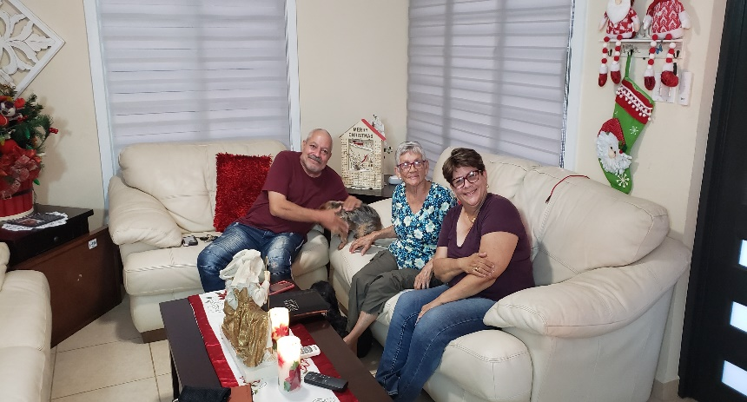
In November I started a weekly online bible study through Zoom where we have been studying the book of James. We just finished the last study of James last week and now I am planning on doing an overview of the Old Testament. The study is obviously in Spanish, but it is open to anyone who has interest in participating. We usually have members from the Arecibo congregation who join in the study, but this past month we had a non-Christian named Alexandra (who is Puerto Rican but lives in Kissimmee, FL) join our study. Over a year ago I had met Alexandra through studies with sister Yadimar in Arecibo. She used to join our studies through video calls, but had stopped studying with us for a long time. I was very encouraged to see her return to the studies and I am hopeful that she remains dedicated to the studies.

Thank you to all those who prayed and asked about brother Edwin Quiñones’s condition. Edwin is doing better, thanks be to God, but he is still struggling with some on-going health challenges. Edwin and I have continued our studies on marriage and divorce and Edwin has also been a big help to me in the online studies in the book of James. He and I have had the opportunity to visit and study with many people. Sister Diana, who lives in Camuy, has a non-Christian mother, named Gloria, who visits her often. Edwin and I have been giving studies on the book of Matthew and both Gloria and Diana seem to be learning a lot from them. I hope and pray that Edwin’s health improves over this next year. Thank you once again for your prayers on his behalf.
Bible study with Edwin, Gloria, and Diana

Over the past two months I have been spending more time with Alvaro Andres and Alejandro who are both sons of Alvaro Jirau and they are members at Arecibo. They are both young men in their early 20s and I have been studying with them more and helping encourage them to grow and be more active in the work. Alvaro Andres has invited me to several bible studies and has put me in contact with some of his non-Christian friends in the Dorado area. Alvaro Andres and his family live in Dorado which is about 45 minutes east (towards San Juan) from where we live. Alvaro Andres has started up his own real estate business, so he is pretty busy, but he has been taking steps toward growing more. I was able to help him prepare some studies and he led a bible study at my house this past month on the topic of “Christians and Dating.” He did an excellent job, and I am hopeful that he will continue to progress. Through some of these studies we have been able to grow a bit closer with the Jirau family and we are thankful for that relationship and hope we can continue to grow together for the strength of the group in Arecibo.
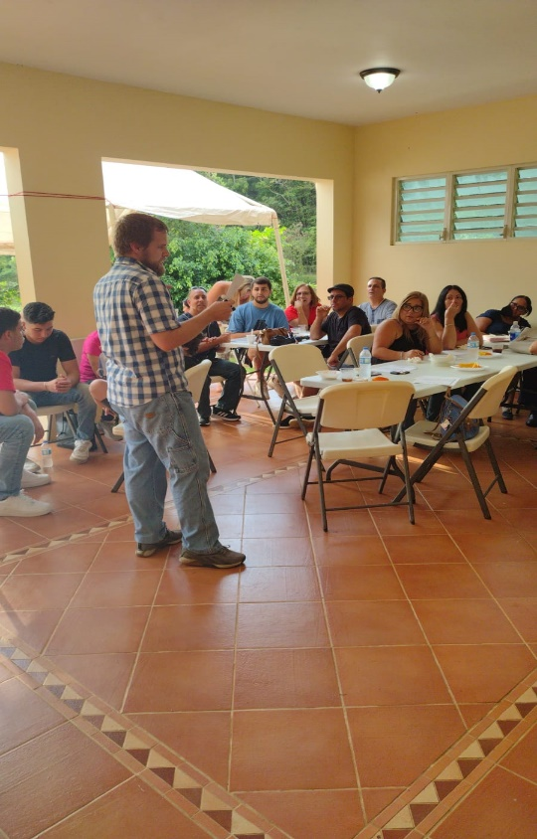
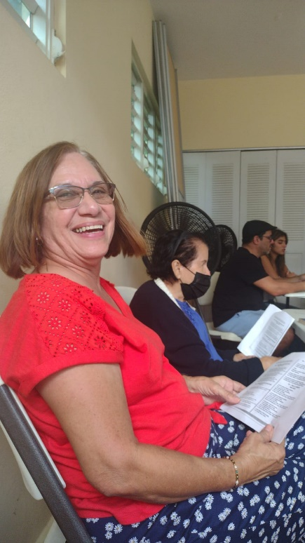
Over the past two months, Kaitlin and I have had the blessing to open our home to many people. We had a Thanksgiving celebration where we invited brethren from Arecibo, San Sebastian, and San Juan. We had about 25 people show up and it was very encouraging. Towards mid-December, my parents visited us and helped us prepare for the larger get-together we had for the young Christians’ bible study. We had about 45 Christians from different parts of the island come to visit. It was very encouraging, and we had a wonderful time meeting so many people. Alvaro Andres led the study and we also had songs, bible trivia, and other activities. I am very thankful to Kaitlin for all of her hard work. It is a challenge to host so many people in one’s house month after month, but Kaitlin does a fantastic job bringing everything together for these activities. She is truly exemplary when it comes to hospitality. Even though there are still many people here in Puerto Rico who are fearful due to the lingering perceptions of the pandemic, we are trying our best to show people that love, fellowship, and hospitality are what we need, not fanatical isolation or fear.
Young Christians study at our house

From some of these events we have opportunities to open new bible studies and discussions with others. One brother named Raul from an institutional congregation near San Juan contacted me after his son attended our young Christians’ bible study and we had a wonderful two-hour-long study on the topic of the use of the collection. It was a bit humorous because he said to me, “Caleb, I don’t mean to be offensive, but the rumor is that you hold some strange doctrines, do you mind if I ask you about them?” I was more than happy to study with him, and he found out that much of what had been said about me (that I was a one-cupper and that I didn’t believe in the collection in 1 Corinthians 16) was misconstrued. We had a very amiable discussion and he said that he understood my points about the proper use of the collection and would consider them more. He said he would be interested in another study with me in the future.
Sister Haydee from Arecibo at a singing at our house

Arguably the most exciting bit of news from this past month is that the brethren in Arecibo met and offered me an apology for the way that they had treated me and excluded me over the past 6 months. Towards the end of October and early November, I was able to meet privately with brother Rene and Alvaro from the Arecibo group. We had excellent discussions and I think they were primary movers toward reconciliation. Since July Kaitlin and I had simply asked the Arecibo brethren to study the issue of marriage, divorce, and remarriage (MDR) with patience and openness. There was one brother who was particularly stubborn and shut down any attempt to study. Thankfully in this meeting in December he apologized to me and said that he knew the issue was still there but said that he was willing to study it with me. I forgave the brother for his conduct and give thanks to God that there has been significant progress in this area. The brethren at Arecibo decided to reinstate me to the duty roster and immediately they asked me to fill in and teach a few classes on 1 Corinthians 5-6. To give a realistic frame about the situation it should be noted that they called the meeting to resolve these things right before the 3 men were going to be out of town, which would leave the Arecibo group without anyone to help direct or teach in the services. Basically, they said, “Caleb, we need you to participate, so we’re sorry for how we handled things, will you help us out?” Even though this may not have come from the most ideal of motives, nevertheless, the move toward participation and study is a welcome shift and I give thanks to God for His grace and strength that has helped us through this long trial. We are far from full resolution. There is still so much to do. But for the moment, we are past the open hostility stage and have moved to a tentative peace. Thank you all for your prayers on our behalf for this situation. We are hoping to have more studies soon on the topic of MDR and the collection with the brethren in Arecibo.

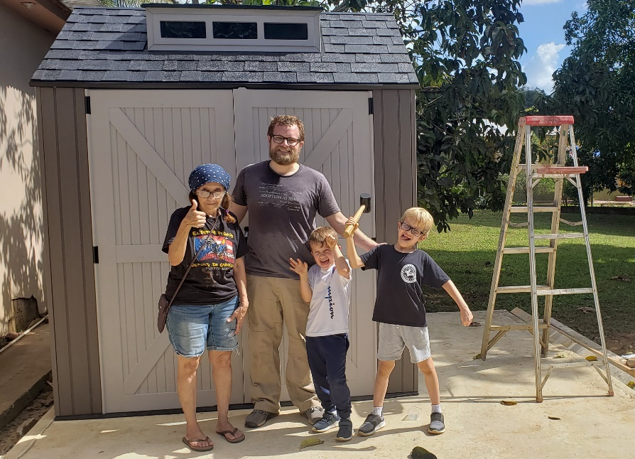
My family and I have also had opportunities to help out other people with projects over the past month. We went to Camuy (30 minutes to the west) where sister Diana lives to help her remove the storm shutters from her house. Hurricane season ends in November so in November/December many Puerto Ricans take off the tormenteras (storm shutters) from their windows that they had put on in July or August. It was a blessing to spend more time with sister Diana and her mother Gloria. We also recently had the opportunity to help sister Violeta (who is another member at Arecibo) put together a tool shed by her house. Sister Violeta lives only a few minutes from our house and she is close with Kaitlin. While helping her with the project at her house she told us a bit about the history of the churches on the north coast of Puerto Rico. Sister Violeta has been a Christian for almost 50 years and she is always very kind and encouraging. I am thankful for opportunities to help and serve and for my family that helps in the Lord’s work in this way.
Helping sister Violet put up the tool shed

Even though it doesn’t relate directly to the congregational work in Arecibo, we have been blessed with the benefit of having more access to various things by living on the north coast. We are only about 50 minutes away from where Joel and Anna Holt live, and we have had the blessing of seeing them more often. While living in San Sebastian we were about 2 hours away from them and the roads to San Sebastian are not easy. Since living closer, Joel and I have been meeting more regularly to study the book of Leviticus, in which Joel has done an excellent job leading that study and I have learned a lot from him. This next year, after finishing Leviticus, we will move on to a study in Revelation that I will lead. Joel and I have also been working on building a film/recording studio at the Caparra Terrace building in San Juan. Joel works with the group at Caparra Terrace. Joel received a very kind donation from some brethren in the states to help purchase video and sound equipment. So, we have been working on building the sets and studios for future video projects. We are almost finished and hope to be able to start doing some video projects toward the beginning of this year.

Work in San Sebastian
The work in San Sebastian continues to go well. It has been a bit difficult these past two months due to the absence of many members due to travel or visiting relatives. I continue to have weekly personal bible studies with Felix and his wife Merri. We are studying through the book of Genesis with them and those studies are going well. I am continuing with studies in the book of Matthew for our bible class and have also recently preached through the book of Colossians. This next month we are looking forward to hosting two young men from New York , Kevlin Arias and Carlos Peralta, who attend with Roger Polanco. They will be staying with me in Arecibo, but they will have several opportunities to present lessons in San Sebastian, Lordwilling. We are hoping they will be built up and encouraged by their work and visit here as we are sure we will be.

There is much to do in the work and we give thanks to God for the open doors and blessings He continues to grant us! From our family, we want to give you our heartfelt thanks for your fellowship and support in our work here. May God be glorified through our joint work for His Kingdom in Puerto Rico. Thank you so much for your prayers, care, and support for my family and our work here. The saints here in PR and my family send you our greetings and our blessings for this New Year! May our sovereign Lord of strength and kindness always lead you and protect you in His constant care!

Grace be with you,

Caleb B. Westbrook

