Puerto Rico Work Report (January 2023)
Caleb Westbrook – HC 2 Box 47421, Sabana Hoyos, PR 00688
713-304-9770/ westbrookcaleb@gmail.com

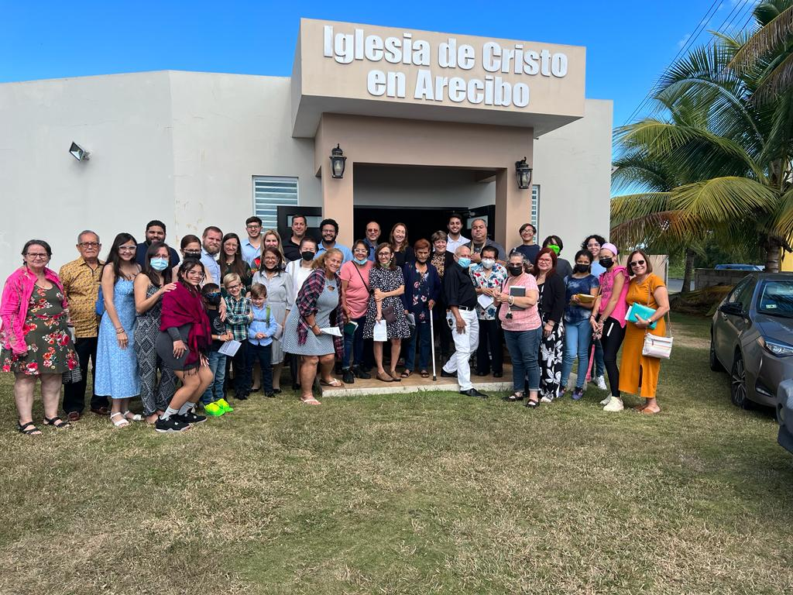
Greetings Brethren in Christ,

The Lord has blessed us with another month of productive work and service for His glory. We pray that the cause of Christ is continuing to grow with the works that you are engaged with. We continue to pray that God blesses your work and that His Kingdom will continue to grow and expand forevermore! Kaitlin and I are very thankful for those of you that have written, called, and emailed us, especially asking about Kaitlin and the baby’s situation. They are both doing well, thanks be to God! Kaitlin has just completed 35 weeks and while she faces pain and discomfort, she is healthy and it seems like we will be able to go through with our plan to have a home birth, Lordwilling. The next month will be very challenging, undoubtedly, but we trust that God will help us through it. We very much appreciate the prayers for Kaitlin, the baby, and all our family.
The church at Arecibo when Carlos & Kelvin were visiting

Work in Arecibo
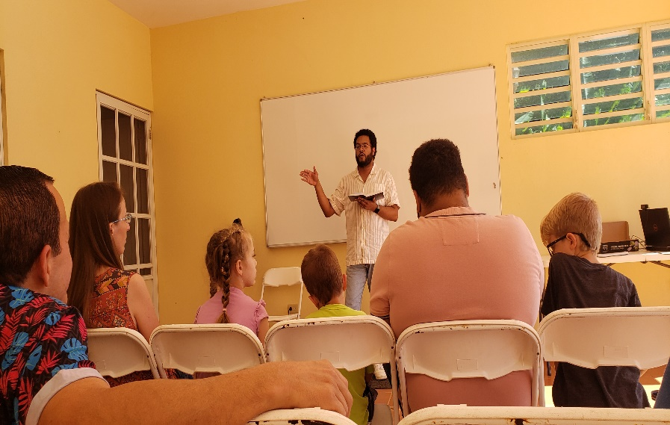
The holiday season finally wrapped up this past month. The Puerto Rican holiday season lasts from the end of November into the middle of January with the celebration of 3 Kings’ day and other patron days and festivals. So, it has been nice to get back into the swing of normal studies and visits with more people here. This past month we had the blessing of a visit from brother Carlos Peralta and brother Kelvin Arias from the congregation of West Harlem in New York. Carlos and Kelvin attend where brothers Roger Polanco and Gardner Hall help evangelize. Carlos had made a visit to PR with Roger Polanco back in 2019 when we were living in San Sebastian, but this was Kelvin’s first time to visit the island. I had been coordinating this trip with Roger for some time to help provide opportunities for Carlos and Kelvin to preach some more in Spanish and for them to help encourage the brethren here in PR. Carlos and Kelvin help teach at West Harlem which is a bilingual group. They both speak Spanish and Roger thought it would be a good opportunity for them to work up lessons for a series here in Puerto Rico. I was very encouraged by these young men’s work and dedication in preparing for the trip and for the sound teaching they brought while they were here. We had a get-together at our house in Arecibo and had about 20 brethren in total attend. Kelvin and Carlos brought lessons on the importance of evangelism at that get-together and they did an excellent job. The brethren here were very encouraged by their message and to see young men preaching the truth. Carlos and Kelvin also brought bible classes and sermons at San Sebastian. It was a very encouraging visit and I hope that they will be able to visit us again sometime soon in the future.
Carlos Peralta leading a bible study at our house

Many of the regular studies have continued over this past month. I have continued to study with Edwin on the topic of marriage and divorce. He and I have also started up a weekly study each Friday on a review of the Old Testament. We had been studying the book of James, but decided to do a review of the Old Testament due to the serious lack of knowledge that most Christians here in PR have regarding the OT. Our Friday studies are open to anyone who wants to attend via Zoom and we also broadcast them on Facebook. We have had several participants from the Arecibo area and have had good participation on our recorded studies on Facebook as well. Additionally I have been continuing my studies with Edwin’s brother Tony, who preaches for the church in Aguadilla. This past month Tony brought one of the new members from Aguadilla, Miguel, to one of our studies. Miguel used to attend a group in Aguada (which is a town on the western coast of PR) and that church of Christ is infamous here on the island for allowing for women to serve as preachers, teachers, and leaders in the church. Tony had informed me that recently several members had left that group in Aguada to start attending in Aguadilla. When I arrived Tony asked me to help lead a study for him and Miguel on the roll of women in public teaching and participation. We studied 1 Timothy 2, 1 Corinthians 11 & 14. The study went well and I knew that Tony was recording the audio of our study, as he does with all of our studies, but little did I know that Tony was going to share that study with all the members in Aguadilla. Thankfully, Tony told me that it was well received by the members. We have continued our studies with Tony and I am thankful for the good fruit that is being born from our efforts with him.

Bother brother Edwin and sister Yadimar have both been a bit sick this past month, so our studies with them have slowed a bit. I would ask that you especially pray for sister Yadimar. She is facing a lot of challenges right now, both physical and spiritual and is in need of much pray. I pray that she will recover and overcome what is facing her right now. This past month I had the opportunity to help sister Margarita Felix with some projects at her mother’s house. Her mother is very old and has to be cared for daily. It is a challenge for sister Margarita, and we have been trying to encourage her in that work. My boys helped me as we cleaned and resealed the roof on her mothers’ house. I am grateful for the opportunities to help serve others here in Arecibo and get to know more people in the process. This past month has also brought opportunities to study more closely with Alvaro Andres and he has agreed to serve as my backup over the next few months if I cannot make it to San Sebastian due to emergency situations with Kaitlin and the baby. I am thankful to see he is growing more in the work.

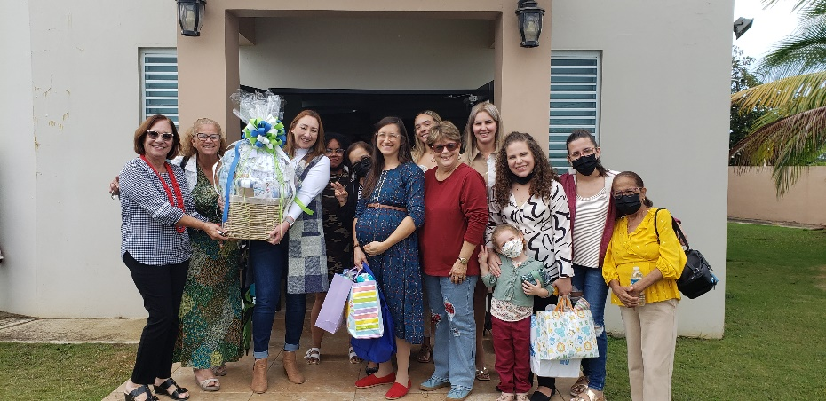
At Arecibo we have been blessed with more visitors to the services and studies over the past month. Two such visitors are Genesis and her sister Victoria. These two young ladies have been very diligent in their attendance and have paid close attention to the lessons and classes. Kaitlin and I have been consistently trying to get them to have dinner or a bible study with us, but they are both very shy and seem hesitant to the idea. Nevertheless, Kaitlin has been corresponding with them over Whatsapp and we were very excited when, after one of my sermons at Arecibo, Genesis (the older sister) started asking Kaitlin questions about baptism. We are still waiting for them to give us a green light on the bible study, but we are hopeful and prayerful that these two young ladies will come to Christ. Kaitlin has been doing a great job with the continued ladies studies each week and she does a remarkable job at helping encourage and stay in touch with the sisters in Arecibo and San Sebastian. This past month the sisters at Arecibo brought her baby gifts after services. It was a lovely gesture and goes to show how much Kaitlin is loved and respected by the sisters here. I am so thankful for Kaitlin’s dedication and work with me for the gospel’s sake here in PR.
Kaitlin with the sisters from Arecibo

Work in San Sebastian
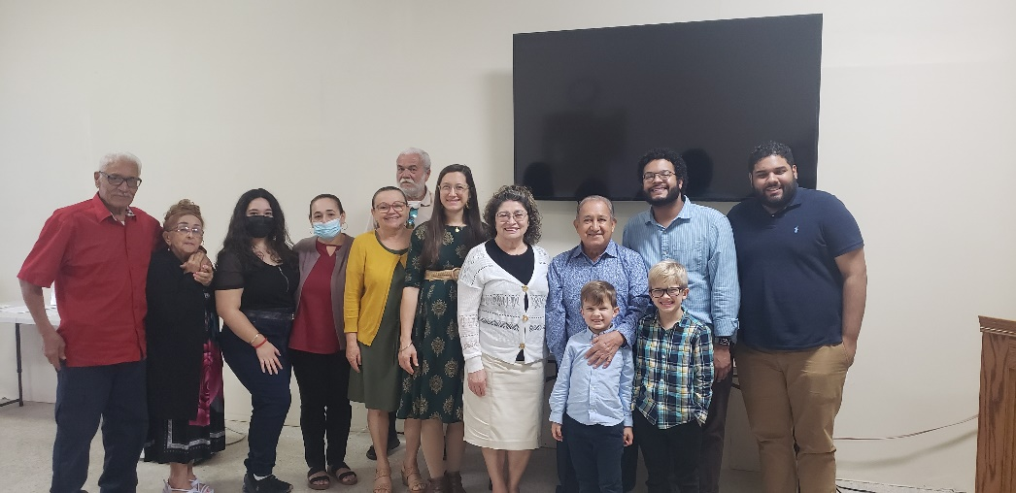
We travel to San Sebastian each Sunday and Wednesday to continue to help the work of the Lord there. I have been continuing my classes in the book of Matthew as well as presenting sermons each week. Additionally, I have continued the personal studies with Merri and Felix each week and I am happy to see their interest and growth. This past month we were thrilled that Carlos and Ramona Moscoso returned from the hiatus in the states. It is encouraging to have them back and to have their help with the work in San Seb. The brethren at San Seb really enjoyed the work and lessons that both Carlos and Kelvin brought. They were greatly encouraged by their work as was my family and I also. It was a blessing to be able to study God’s Word together.

There is so much work to do, but we give thanks to God for the opportunities and open doors that He provides. Please keep me in your prayers as well as my family. I have been battling a rather stubborn respiratory infection that has been quite bothersome to me this past month. I struggle with allegories and asthma problems and my doctor told me the PR is the worst place in the world for that stuff. Nevertheless, we have confidence that God will provide and give us strength. Thank you so much for your prayers, fellowship, and continued support in our work here. If you ever have any questions, doubts, or comments about our work here, please feel free to contact me anytime. May our blessed Father of light and truth always bless and prosper your way!

Grace be with you,

Caleb B. Westbrook

