Puerto Rico Work Report (late March-April 2023)
Caleb Westbrook – HC 2 Box 47421, Sabana Hoyos, PR 00688
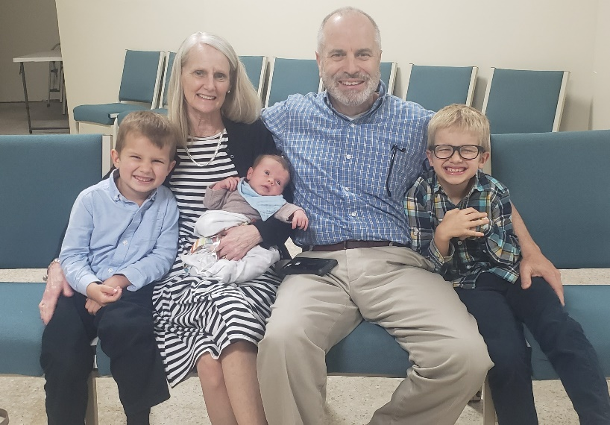
713-304-9770/ westbrookcaleb@gmail.com

Greetings Brethren in the Body of Christ,

Thanks be to our Lord God above my family is doing well. The first couple months after having a newborn are always challenging. Kaitlin and I are in that zombie stage where we are quite sleep-deprived. 0Nevertheless, Nehemiah and the other boys are healthy, and we are trying our best to juggle everything. Kaitlin has been doing well, especially given the post-partum challenges that are present. We were blessed to have Kaitlin’s grandmother and mother visit us for the month of March and my parents came to visit us for a week in the beginning of April. We are grateful for their visits, but it is difficult living so far away from family and not having a consistent source of nearby help and support. Nehemiah had a frenectomy (tongue-tie cut) this past month and has had plenty of doctor’s visits too. We thank God that both he and Kaitlin are healthy and doing well. The harder challenge for both Kaitlin and me has been a bit of exhaustion and burnout. With the lack of sleep and the continued workload without much support, we feel like we are spread thin at the moment. We would greatly appreciate your prayers for us. We know that this is a season of transition, and we have confidence that God will provide what we need and even more. We give thanks to our Father for the blessings and strength that He gives to help us continue forward.
My parents with our 3 boys

Arecibo Work
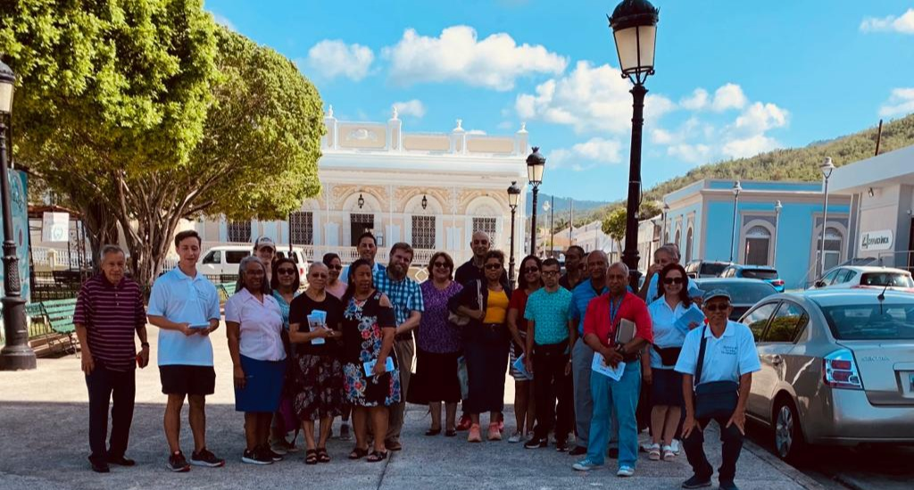
There has been a lot of work and opportunities here in Arecibo this past month. I have had new bible studies with some of the visitors and have had new contacts. This past month I was finally able to have a study with John, Genesis, and Victoria. They are three young people that have been visiting the church for the past several months, but it has been very difficult to get a study with them. This last month I was able to study with John personally as well as have a group study with all 3 young people. They face many challenges from worldly influences, but I hope and pray they will grow closer to God and that there will be more opportunities in the future.

God has opened up a door for me to return to studies with a young Christian named Yan from Arecibo. Yan and I had studied in the past, but he had dropped off the radar for a couple of months partly due to the fact that he and his family do not attend in Arecibo, but travel to Caguas (about 1 hour away). This past month he and I were able to reconnect and do a lot more studying and conversing together. I invited Yan to travel with me down to Guayama (south Puerto Rico) to participate in a public evangelism effort put together by brethren on the south side of the island. Yan and I spent several hours together and I was really encouraged by my studies and talks with him. Yan comes from a difficult background, but I am hopeful that he will continue to study and work with me.
Yan and I with the evangelistic effort in Guayama

This past month I have also pushed the Jirau boys, Alvaro Andres and Alejandro, to be more consistent in bible studies with me. We have had several studies together and I think they are making progress in their spiritual growth. I was also able to study and talk with their parents, Alvaro and Leymar, who are members at Arecibo as well. I have been blessed to see growth in the confidence that the Jirau family has in me, and God has opened up a lot more opportunities for discussions and studies with them. The youngest son, Alejandro, is dating a young lady named Ainoa, who has attended services serval times, but has yet to agree to have a study with us. Ainoa is a nominal catholic, but her family is deeply rooted in Catholicism. I have begun classes with Alejandro to try to help equip him to study with her about the Bible, faith, and tenets of Catholicism. It has been a slow work, but thanks be to God there seems to be progress.

So much has changed in Arecibo over the past year. We went from nearly being expelled from the group by a few of the brethren last fall, to now I am asked to preach on the monthly schedule and recently the brethren have asked me to teach each Sunday morning for the bible class hour. Over the past month, I have presented a deep-dive study on Matthew 24 and apocalyptic language. Most brethren in PR assumed that Matthew 24 in its entirety was talking about the second coming of Jesus and almost none of the brethren had ever studied the chapter at all. So, I have been leading a detailed discussion and study of the Old Testament prophetic references in Matthew 24. This study has been a tremendous blessing and the brethren are learning a lot. Further, I think they are starting to see that good Bible study is based deeply in the scripture and not just in whatever the “church of Christ” tradition or doctrine is. I am hoping that there will be opportunities to continue with further studies after the Matthew 24 classes finish soon. I have also been continuing my weekly studies on Fridays on “An Overview of the Old Testament.” We have regular participants from the congregation in Arecibo and the studies are recorded and available on my evangelism page facebook.com/SoloUnCristiano or on the Iglesia de Cristo en Arecibo page on Facebook. We have had a good number of views on our study and many brethren from different parts of the island have commented to me that they listen to our studies. Very few brethren here in PR have ever studied the Old Testament and I have never taught an overview class of this style, so it has been a growing experience for everyone involved. We already finished the book of 1 Kings and it is my hope to finish the entire Old Testament within this year, if God wills.

There have been a lot of changes and open doors in Arecibo and throughout the island in regard to discussions on institutionalism. I will not mention all the details here, but if anyone is interested in hearing about the details of these challenges, discussions, and engagements with institutional brethren here I would gladly provide more information directly. Suffice it to say, God has blessed us with many opportunities to study and engage with brethren on this topic over the past month. Some people (a few from institutional churches in the states) are not happy about my work and influence among the Puerto Rican brethren. I have been publicly called out by a few people, but this attack against me does not seem to be having the effect that they desire. More and more people are starting to realize that the ugly title of “Anti” does not fit with what Kaitlin and I are professing and doing. More brethren are starting to realize that Kaitlin and I are simply inviting people to return to basic New Testament Christian practices. Even though there has been quite a stir this past month, I give thanks to God for all the progress that we are making on this front. To God be the glory!

Evangelism in Southern Puerto Rico
As I mentioned earlier, this past month brother Yan and I had the opportunity to travel to Guayama (south PR) to help with some evangelistic efforts. We passed out flyers and Yan and I had a very interesting study with some Pentecostals that we met in Guayama. We give thanks to God for the opportunity we had to share His gospel. This was a tremendous opportunity to also reconnect with some of the brethren from Ponce (also in southern PR). It has been a long time since I had contact with the members at Ponce. When I first moved to PR I spent a lot of time working with brethren in Ponce and Yauco, but over the years my attention moved more towards northern PR. When Eric Huggins was working here in PR he would regularly go to Ponce to preach. Since I have moved to Arecibo I have only had contact with a few brethren from Ponce only once or twice over the past year. So, I was excited to see some of them again and reconnect. I was greatly encouraged to hear that the work in Ponce has been going well and that over the past few months, they have baptized 4 young people. I was able to reconnect with brother Enrique from Ponce and he and I have planned some studies together for the future.
Marisol’s baptism in Ponce – Photo courtesy of Enrique

San Sebastian and Future Work
The work in San Sebastian continues to go well. It can be a challenge at times to make the trip all the way there. San Sebastian is about an hour’s drive from our house and the road passes through some difficult mountain areas. Kaitlin and the boys have been so supportive of our work in San Sebastian, and I am thankful for their company and participation with me. I have continued teaching classes in the book of Matthew and preaching every week in San Sebastian. I also have continued my weekly studies with Felix and Merry. We are studying through the book of Genesis together and I can see definite growth in Felix as he learns more about the Bible’s story. I have been trying to encourage the members to focus on evangelism and reach out more. The brethren in San Sebastian have been receptive and they have also been very kind, patient, and supportive of my family and me during this time of transition with the newborn baby. There are so many open doors and opportunities here in Puerto Rico, but the workers are few. I have been trying to reach out to find faithful brethren who might be interested in moving here to PR to help with the work. Sadly, we have had no response, but we continue to pray and hope for God’s help and provision. We are working on plans for future evangelistic efforts both in Arecibo and San Sebastian. I am hoping to write more bible class material soon to use in San Sebastian and possibly in Arecibo. Please pray for our gospel efforts here.

Even though we are tired, we will not give up. We will continue to march forward with the message of the gospel through the help and sustenance of God’s grace. We are so thankful for your fellowship, prayers, and support on our behalf here in Puerto Rico. We pray that our gracious Father above blesses you and the saints where you work with abundant growth and strength for His glory! If you have any questions about our work here, please feel free to contact me anytime. May God bless you all greatly!

Grace be with you,

Caleb B. Westbrook

